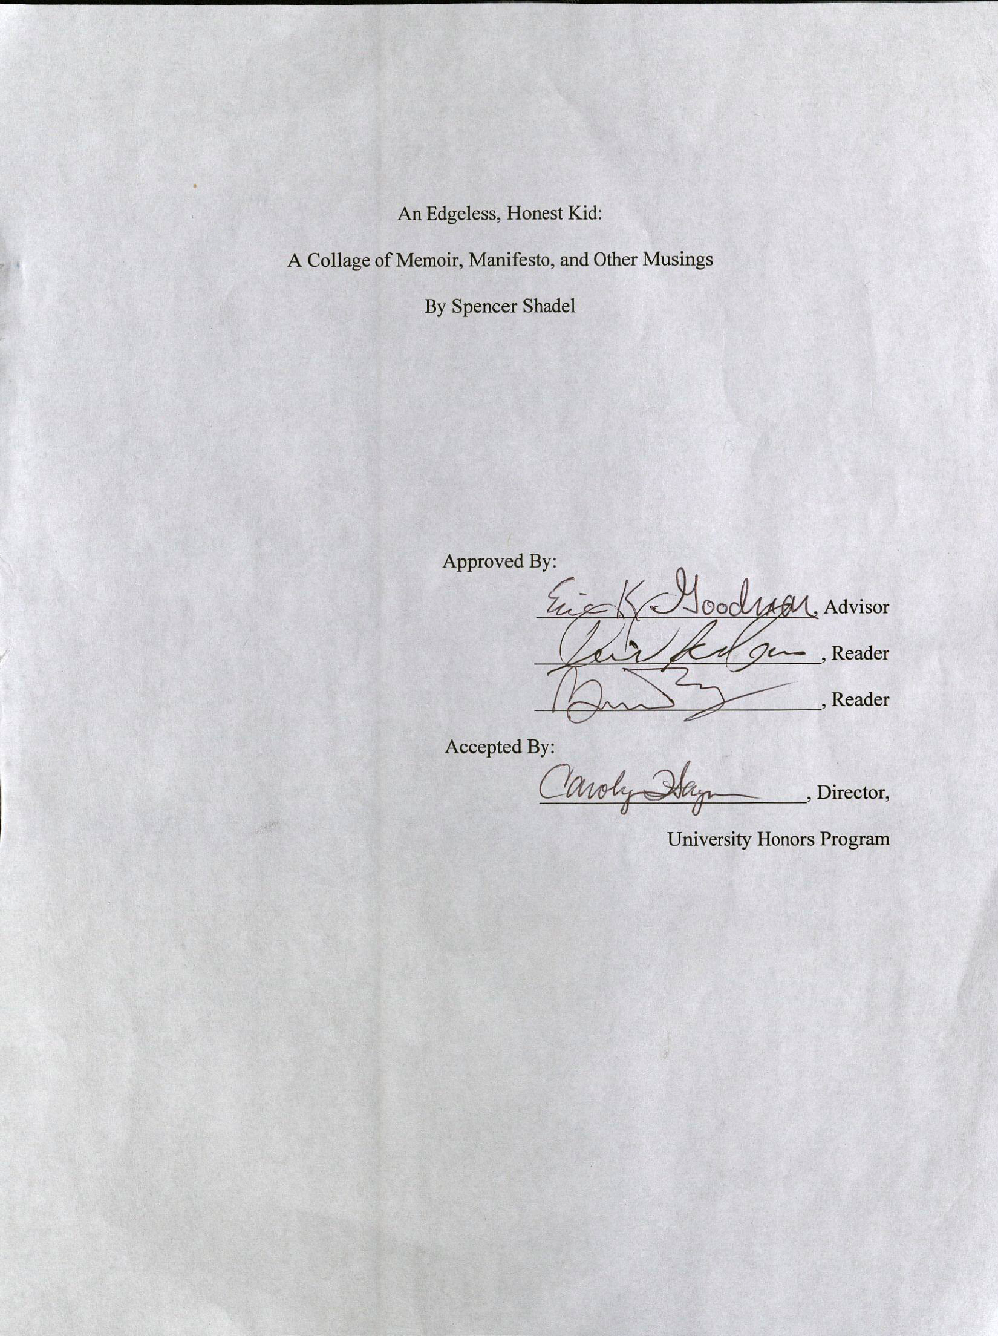

An Edgeless, Honest Kid:
A Collage of Memoir, Manifesto, and Other Musings

Spencer Shadel

Introduction
This project came to life in my creative writing capstone my first semester of my senior year of college at Miami University. I had to put together a ‘novel-length project proposal’ for the end of the class assignment. As I already had a novel premise on my plate for my senior thesis, I tried to come up with a non-novel project that would accomplish two goals: one, I wanted to give life to some of the things I had written throughout my collegiate career that were buried on my computer’s hard drive and threatened to remain there forever if I didn’t find a project to work them into; and two, I wanted to explore the area that had yielded some of my favorite works—and by ‘favorite’ I mean, I suppose, emotionally and stylistically exciting—an area that seemed to me to be some kind of marriage of personal memories and sound-play. The idea that emerged from those qualifications was a multi-genre memoir, a project in which drawing from memory would allow a lessened eye on plot and the collage format would allow for meanderings between genre, style, tone, and voice—with the primary benefit being an opportunity to simply play with and in words, to explore boundaries of sense and of my personal aesthetic, to sculpt for pure personal pleasure in my favorite mediums. As it developed (and my inability to figure out novel writing became apparent), I adopted this opportunity as my thesis project.
What this has turned into from there is a series of snapshot looks at the people I have been and an attempt to emotionally root a cynicism I’ve unlovingly developed throughout college. Why I went from the happy blonde boy with the bull cut
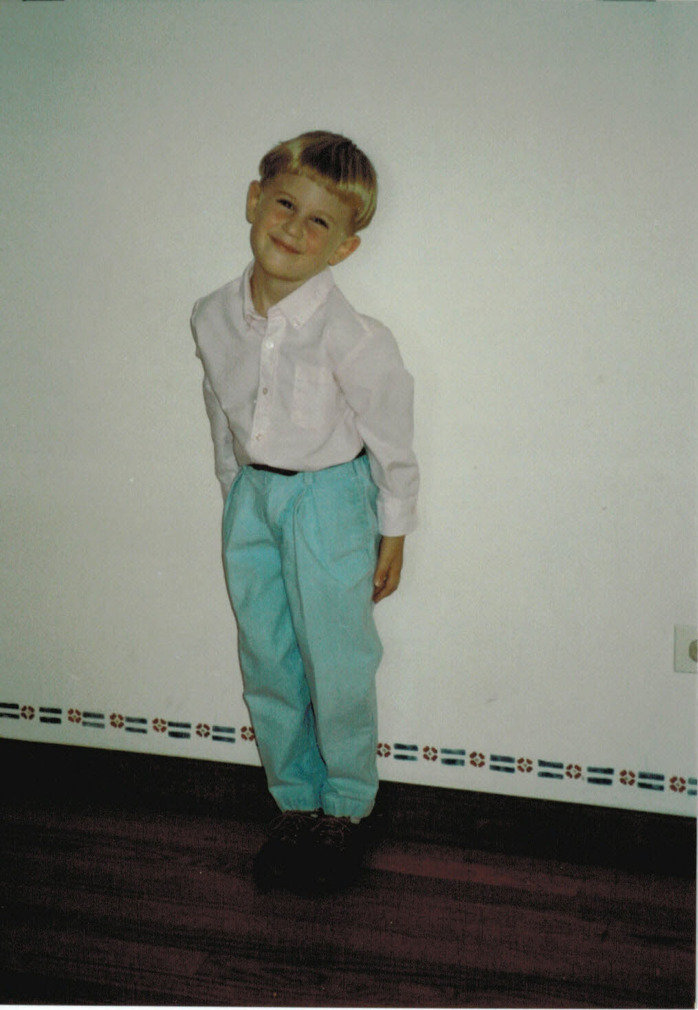
to the moody shy kid who’s kind of an asshole. How my love for people and life could have been so Whitmanesque but before I knew it became saturated with pessimism and why, or am I wrong to think I had the potential to be generously compassionate—was I always this way?
Sometimes that investigation materialized in non-fiction prose. Sometimes it turned into fictional stories, sometimes poetry. Sometimes it’s not an attempt at investigation or explanation but just something that feels relevant, a dream, a photograph, a jotted-down thought from a years-old journal, a few lines of lyrics that have so deeply permeated my mind that I carry them from one self to the next. Not all of this text makes sense, and hardly any of it has been demarcated by genre. I claim it all as non-fiction just as I claim it all isn’t; I’ll leave the understanding and sense-making to you.
Onward, to truthful lies.

The Early Years
What There Was Before I Can Remember
There was a house I never saw for two years and a move to my first home. There was kindergarten potty training. There was a backseat ride from somewhere to somewhere with a wicker lap basket full of blanket and a yellow-collared puppy my brother lobbied for before I could. There was an exchange while we clambered over her, sleeping on the stair landing in a lateday window sunsquare, and I said I wished I could live her dream days, and he laughed at me and told me I wanted to be a bad word that I would learn when I was older.
There was that time Mom and Dad were on vacation and Auntie Julie was babysitting us and I threw Ana’s hairband off the second-story banister because I wanted to impress my brother but he switched sides after they saw it had broken and she started crying.
Hot summer days and the sliding door in the kitchen to outside to the grass and the tree house and watching sunsets over dinner. Fireflies, grasshoppers, prairie grass dances, mosquito candles or sometimes instead my father’s cigars. There was my leather mitt I left in the backyard that rain ruined and so never got another. And there was the neighborhood kid who was getting scouted by the majors so my friend and I figured out when he was practicing and biked down to the school and found him throwing balls against those bounce-net practice stands and watched him and asked him to sign our gloves in case he ever got famous. If he ever made it or if that glove was the same as the rain glove, I don’t know.
There was practicing figure eights on our bikes in the school parking lot after dinner with my dad and my sister, in the transition from sunlight to streetlamp, and that feeling of going fast and of being fast.
There was the first time my life savings hit $15 and I brought it all out to my mother while she planted yellow flowers on the side of the house and I was so excited and she congratulated me with what I thought was real pride. And also when I learned to read aloud and showed her while she was working a steaming pot and didn’t have time and told me I already knew how to read so maybe I had learned before I remember learning.
There was the time Auntie Julie chased crying me around the first home for two hours wielding a flu shot until my dad got home from work and I shut up.
Fresh grass cuttings glued to my feet by the sprinkler water. Grass that was as wholly and as intensely green, and dirt as purely brown, as careful crayon drawings with all the right colors.
My brother and I buying Pokemon Blue to share and it only having one saved file slot.
Not wearing anything but sweat pants and my socks having to be inside out.
That older neighborhood kid who stole my toy rifle and I didn’t know how to get it back because when I found him and asked, he was in his tree fort and pretended not to hear me.
That neighbor girl who convinced me to eat a seven-year-old chocolate candy—that chalky taste.
There was my brother, Brent, complaining or yelling or something and that quick-spin, reach-out, clamp-down of my father’s angry hand on his upper arm, the pulling into his office and a raised-voice lecture behind a slammed-shut door.
There was the need to please.
There was mac-n-cheese and apple slices and milk for so many dinners and the fights with my mom over not finishing it, the fights over swim lessons I didn’t want.
Piano lessons I didn’t want.
There was being unsure and living on instinct.
There was my dad’s sports car with only half a back seat that hurt my legs but had a spaceship-green dash. And that big blue Ford van from before that I once rode in sitting on the floor without a seatbelt and felt either elation or fear and my dad told me something and there was either a radio playing or a passenger speaking.
There was only family, and trying to impress.
There is little of what there was. No video. Just still-shot frames, colors, textures. Smells, the vague semblance of emotions. A few words. My parents’ memories.
My conscious life began at ten.

Unimportant Pocket Notebook Thought #1:
My father is the only grown man I dare to
tease, and it is because I know I make the
same mistakes he does.

Day One
For some reason my glasses had ended up buried in a box in the U-Haul, so the first time I saw our new home I couldn’t actually see it as anything more than a looming grey blur. My dad had moved some months earlier to start his new job, and at the end of the summer my brother, mother, sister, dog and I followed.
It wasn’t really the first time I had seen the house. My parents had dragged us around to all our potential new homes on an earlier trip. I remember hot sunny days, my mother’s warnings to watch out for nails as we adventured through the stark, wall-less outlines of unfinished houses, taking turns drinking water from bathroom taps when my sister and I were thirsty and tired. Driving, and more driving. But I don’t remember having seen the one we chose on that first trip. The one my parents chose.
But the first memory I have of it—when we drove down Forest Run Drive to the grey-faced residence to re-join my father and passed a group of boys my age playing whiffle ball in a front yard, and I, without my glasses, couldn’t see any farther than the windows of the car—doesn’t come with a first impression. It comes only with remembered hesitation—the response to my mother’s suggestion to “go play ball with those boys.” Boys I didn’t know, whom I hadn’t even seen, whose existence I had to accept at my mother’s word. After her initial suggestion, she spoke to me without eye contact, too stressed and occupied to look at me. There was a brief debate with the back of her black bob, a failed attempt to convince my older brother to come with me, and eventually a leaden-legged trod down to the game being played three houses down.
I trundled up to their game: Reeboks and white ankle socks, those acrylic khaki pants that zip off at the knees to become shorts, a blue t-shirt with a large-eyed alien face on the front, and a blonde bowl cut and squinting eyes that sorely missed my gold, thick-lens, circle-rimmed glasses. One of these kids would go on to play wide receiver at Syracuse. Another, inside linebacker at Michigan State, and another, cornerback at Otterbein. Two went on to play collegiate basketball at small programs. One is a Marine. I was fated only to the body of a cross-country runner and novel junkie, was paler than Casper, and weighed less, too. So trundling up, that nervous boy I was knew from physical stature alone, knew from my temperament alone, knew from each one of their free-flowing gym shorts alone, that I wasn’t going to make the right impression.
But they were friendly kids, and asked me if I had just moved in. Invited me to play, let me go up to bat as soon as I wanted. I tried to stammer out, “I don’t have my glasses.” But then there was a bat in my hand, and they were looking at me.
Why couldn’t they have been sitting out in the grass with books in their laps? Have had a row of chessboards set up? Or been inside, playing video games like me and therefore not be seen by my stupid mom? Where was my brother? Where were my glasses?
I took one swing, and missed.
I re-set my stance, re-gripped the bat, and looked out again at my new neighbors, who—as far as I could tell—were still watching me expectantly.
Another swing, another miss.
They were playing with a tee-ball, but still had someone pitching it, underhand. So while it wasn’t a stationary ball exactly, my face was beginning to redden. I re-set myself once more.
A third swing, a third miss.
I didn’t even like sports.
A voice from the other side of the yard, to the pitcher, offered me more chances. I couldn’t tell from whom, but there wasn’t much dissension.
A fourth strike, and a fifth strike, and then I gave up the bat for the day. I stuck around for a little while, dropping balls and tripping, mumbling apologies and excuses, before slinking three houses back down the sidewalk to that grey-faced stonewall façade. I’d like to say that same voice from the outfield yelled out an invite to me as I left, or that one of those guys gave me a pat on the back or a smile or an acknowledgement, but I don’t remember anything like that. Not that day, at least.
I only remember walking back to a foreign home with blurred vision, and demanding my mom explain why I didn’t have my glasses. I can’t recall her reaction to my pestering, only her black bob—the blur of her walking away.

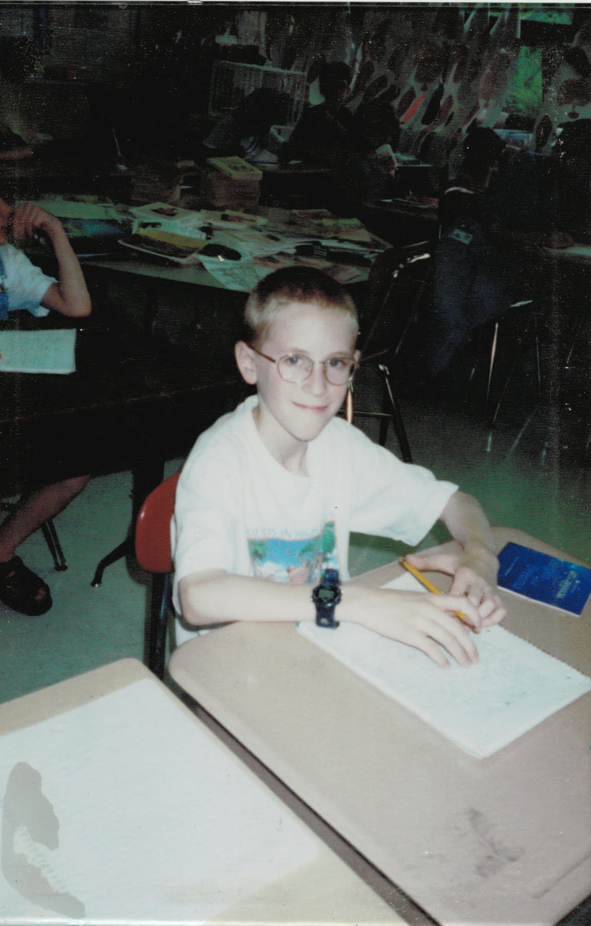

I Shed and Parse and I Cannot Rely

Sea corpse whispers rise, rise, pop and hiss:
slippery mist amid the daily surface rain,

indicting all my childish frame and nature,
and nature with what rhyme or reason
directs a barefoot memory?

shame? remorse? excitement? faces?—
reaction shots to dictate audience
response—re-memory re-read
by aged minds: Then-minds telling
my-minds to remember, clutch
for when the now can understand.

(or re-understand, myself, I can’t)

I dream of speech I catalog as
memory to be proven wrong
when no one else recalls my words.

exorcising drama like demons
flushes moments to the oceans:

I’ve left years in deep black leagues
of eyeless fish and all my former selves

High School
Varsity Letter
Step out the front door of my Columbus residence and cross the street. Follow it until it curves to the right, and then abandon it for the bike path on your left. Depending on the season, it will be overgrown with brush or buried under fresh snow or dead leaves, so look for it carefully. Follow it to the right until you emerge from the tree line. Coffman Stadium will be framed against the horizon to your left. You won’t miss it.
About 100 yards farther and you pass through the double gates, stepping onto the fiery orange track. In the winter, the snow will ruin its glow, but in the summer or fall the track burns with energy it seems to absorb from the sun and heavy air around it. I remember each of a multitude of races run on my home track; the raucous sounds of fans and athletes alike, the smell of the rubbery track and field turf underlying the collective stink of sweat that hovered in invisible trails in the air, the stadium hot dogs always waiting at concessions to cover up the stale taste in my mouth after a meet, and the heated foot massage I receive walking barefoot on the track itself.
Just inside the oval track, the football field sprawls quiet and pristine. The white and yellow lines are almost as radiant during the day as they are at night when they reflect the blaze of the towering stadium lights. At this point, make your way to the center of the field and lay down in the middle of the painted shamrock. You can feel the memories contained in the field: countless seasons of soccer, football, and lacrosse reside within. The field can still tell you stories of athletes’ realized aspirations, the undefeated regular season record of 2008’s football squad. It can still recall my footprints, among many others, as we rushed the field to celebrate with our team after victories.
The memories that come to the forefront of my mind, however, are my personal track accomplishments. In particular, the last dual meet of my sophomore year. I had scored six points on the season; half of what was necessary to earn a varsity letter. I entered myself in the mile and the two-mile races. In both events, winning the race earned a runner five points, second earned three, and third place garnered one point for his team. I called my dad before the race, told him I was going to earn my first varsity letter today, and demanded his presence in the stands. He arrived just before the mile began and witnessed me nab three points and a second place finish.
Despite my good showing in the mile, there was little celebration between us; we both knew anything short of second place in the two-mile race meant I wouldn’t letter. Before my warm-up, he clasped my hand, pulled me into an embrace, and told me that I needed only to focus on getting those last three points and I would be fine. My muscles already fatigued from my first race, I recognized his wisdom and thought past my body while waiting anxiously for the two mile to begin. As I stepped to the starting line, feeling my father’s eyes on my back, I mentally prepared for whatever the other runners were going to throw at me.
As the race unfolded, two Upper Arlington runners and I separated ourselves from the pack. With black and gold uniforms on either side of me and lactic acid flowing through my veins like agent orange, I kept my stride even and hoped that if I could just hang on, I might be able to out-kick one of them and win my varsity letter. As we started the last two laps of the race, the pace quickened. One of the Upper Arlington runners quickly outdistanced us and with first place prematurely but convincingly out of reach, it became a two-man race for second, for three points, and for my varsity letter. I blinked hard, trying to defend myself from the stinging, salty sweat that poured down my forehead as we both pounded our spikes against the track in trying to pass each other.
Coming down the home stretch before our last lap, my father’s voice boomed through the crowd: “Letter! Finish and letter!” My opponent passed me to start the last lap. I took the lead back before the backstretch but just as quickly relinquished it. His lead was building; five, then ten meters separated us. I was fading fast, my legs were dragging, and my feet were heavy. The 200-meter mark came and he was holding on to his lead. The last race of the last meet of my season was quickly coming to a close—and it was ending in defeat.
Two things happened. My opponent, whom the quiet crowd had assumed was about to surge out of my reach, faltered. He had too little of a final kick, having worked so hard already to build a lead on me throughout the last lap. At the same time, my desire and determination manifested beautifully. I pumped my arms and brought my knees up while turning my legs over faster and faster. As the other runner struggled to finish the race, I turned on the jets. The home crowd, led by my boisterous dad, cheered on the spectacle as I torched my opponent down the final straight and claimed second place by a solid thirty meters.
While I was excited simply because I had earned my varsity letter, my dad was clearly proud of me on a different level. Not only had I accomplished a huge goal, but I had done so with moxie and verve in a high-pressure situation. He still likes to recount this story when we talk about running, and sometimes I think he takes more pride in the memory than I do. And to a certain extent he’s justified; if I say I could have done it without his support I would be lying.
As significant as my dad’s support was to me, he is far from the only parent to cheer their Coffman student to success. And as special as my memories are to me, my accomplishments represent a meager fraction of my high school’s illustrious past.
So as you lay on the bristly turf of Coffman Stadium’s football field, think about the history of this place. Think back to its establishment over fifty years ago. It has witnessed more victories and defeats than you or I will know. Stories like mine, which may not mean much to most of Coffman’s alumni, are its backbone. Our great successes are its heart, and our pride its soul. Pondering all this, you might realize how honored I feel to have been able to contribute my own stories, however diminutive, to the vast history of its existence.

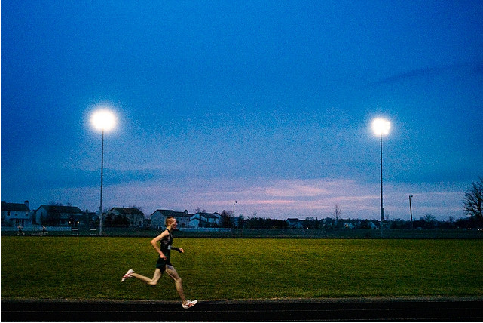
Rage, Rage Against the Dying of the Light

That was the gist of high school. Academic successes and some athletic successes. Personal gratification, school spirit, and enough dating to learn from girls who thought that I was smart that I’m a stupid asshole. The rest of my life has pretty much been dealing with that truth.
It took forever to get to high school, longer to endure it, and an instant for it to end.
It was ordered, though. The formal parts of it, at least. Which made things easy. Or clear, at least.
I spent a lot of class time sleeping or doodling or scribbling “poetry” on lined notebook paper that I folded into eighths and buried in pockets to later feed to the washing machine. I read a lot. And then I woke up in college with the realization that I didn’t have the faintest idea how to go about the things I thought I wanted to do.

Unimportant Pocket Notebook Thought #2:
I lost my pen, unfortunately, but hope to
find it still.

Freshman Year
Every Monday, Wednesday, and Friday at 11:45 I leave Tappan Hall and bike up Maple Street’s busy sidewalk. I cross Spring Street, and continue on to Laws Hall through the lunch-hour rush. There are people everywhere, often so many that I have to bike on the street, or not at all. I feel weak as I pick my way through the crowd, as though I am skinnier and paler than I have been the past few years. I feel like a stranger amongst the crowd, even though they are mostly fellow students. Every Monday, Wednesday, and Friday I search their endless sea of faces for familiarity. And always, I am left searching. The faces that look back at me offer no smiles of recognition, no friendly salutations, just eyes that briefly meet mine and then snap back to place as they hurry to their next destination.
I look at all these faces, unrecognizable to me, and I cannot help but think of the faces that I have left behind to be here. My father and mother, sister and brother, my dog, my best friends, the rest of my friends, my acquaintances. I think of them daily, and without them I feel a weakness, a hollowness. I think of them as I sit in my small dorm room, doing my homework or chatting with my small group of new friends. I feel an emotion that is almost foreign to me, and accompanies my twangs of homesickness. I think of how I have left my support system behind, how I am here to study by myself and for myself, and I feel a sudden and deep rush of this emotion that is now unmistakable. Loneliness.


One’s Enough

sitting sipping nursing
sitting sucking puffing
stomach pain; pit stains;
dizziness; dense breath.
texting girls, those
stars, Orion’s belt.
here = unattractive
oaks = buds barely green.
watching pong (no
tossing butt (one’s
interest) turned up
enough), stomach
the bass, slip away,
beckoned, door unlocked,
step outside alone,
pass through quick, shallow
with my Pall Malls.
desire leads me.

Unimportant Pocket Notebook Thought #3:
I’d like a world where people do what they
want without anyone ever taking advantage
of anyone else

What I Wrote, Unedited
Dear Mr. Palahniuk,

Six minutes ago I finished your novel, Survivor. The only published writing of yours I have yet to digest is Invisible Monsters. I could talk about your novels for a while, but I would rather keep it succinct. They’re good, and you know that.

What I instead want to talk about is I don’t know. I think suicide but I don’t want to come off dramatic or spoiled. I haven’t suffered in life, my parents have always been good to me, and I’m a smart kid. I accepted a full ride to Miami University in Nowhere, Ohio. I can explain the difference between a myocardial infarction and a thromboemblism and how they’re formed. If your heart gives out someday twenty years from now, I might be the one keeping you alive.

But to be honest, I don’t really care if other people live or die and I don’t want to be a doctor, although that’s what I’ve thought for a long time. My real passion is writing (just not letters; this sucks and I sound stupid because I’m trying to impress you). I’ve always loved writing and I’m changing my major to English so I can continue doing that.

This letter isn’t to praise you because although I could do that quite easily, I’m guessing you get plenty of pure fan mail. And I guess I’m not asking you for advice either because I know I want to write.

But I don’t know anyone else who talks about death like you do. I don’t know anyone who writes about suicide like you do. And I think about suicide a lot. I don’t think I’m depressed or suicidal, I’m just kind of hate a lot of people and get bored with life easily. I think I could be pretty happy writing for the rest of my life—about as happy as I could be, I suppose—but I can’t write like you can. I don’t have the life experience.

I think I’d be dead if I wasn’t so preoccupied with trying to figure out who I am. And my family’s still alive, and I don’t know if I could do that to them. I have like two friends here at Miami, so in terms of this life no big deal, but back home it wouldn’t be right. I guess I want a quick fix, but I know I’m not going to find one. So I can’t kill myself although I want to, I could go into writing but it will be superficial and pointless and forgotten as quickly as it’s read.

You’re reading this—probably not, actually, but suppose you were—and thinking that I’m a lost college kid reaching out for help. I’m a quick diagnosis. Zoloft and counseling for treatment. But I can’t do that. I can’t let my parents know I’m not happy. So I guess I am reaching out. I’m just being a pussy and doing it in a letter. That I’ll never send. And if I did send it, even though I’d want to send you some of my writing to show you I really can write, I wouldn’t because you don’t have time for this shit I know. So I guess you can just forget the whole thing. Sorry to have wasted both of our time.

Yours truly,

Spencer Shadel

What I Turned In, Unedited
11/14/08
Dear Mr. Palahniuk,

All writers welcome praise from their audience, and that is what I hope to provide you with this letter. I, like many of your admirers, first encountered an original Chuck Palahniuk story when I rented Fight Club from Blockbuster with my friends. When Brad Pitt and Edward Norton first exchanged blows in the parking lot of a bar, we all wore open-mouth smiles and raised eyebrows. We laughed at your dark humor and responded with head nods to your often-cynical, one-line truisms. And it took us at least fifteen minutes to pick our jaws up off the floor after the realization hit us that Edward Norton’s character is Tyler Durden. But my appreciation for your craft has developed far beyond the slightly superficial enjoyment my friends and I received watching your blue screen success.
When I first learned that Fight Club the movie had been based on a novel, I made it a priority to acquire a copy. I read your book cover to cover over the course of a few days, barely able to put it down. When I read your work, I felt real for the first time. It was as if I had been going through the motions my whole life, pretending to care about school and small talk, and reading your book opened my eyes. I realized that there were other people in the world who shared feelings that I had been previously unable to put into words—the protagonist’s sense of abandonment, Tyler’s detachment from material possessions, and the acknowledgement of impending—and sometimes pending—doom. I have gone on to read all of the novels and non-fiction work you have published, and I still find an emotional and spiritual connection with each of them.
Recently, I have been suffering from a bout of depression. It’s my first semester as a college student, and I’m struggling in classes and in my social environment. I tried out for the varsity cross-country team, made the squad, and was subsequently spontaneously cut. I want to change my major out of the pre-med track and into the writing vein, but I’m not sure it’s the right decision instead of an easy way out of a bad situation. Everything small and large seems to be working against me and, lacking the support of my parents, friends, and a religious belief, I am struggling just to keep my head above water. I wake up thinking about when I can go back to sleep. Some days I don’t get out of bed at all, and miss my classes. I feel tired and worn like the tattered threads of an old, faded pair of jeans.
The only positive of my sorry mental state is that I have had an opportunity to do some leisure reading again. I read Survivor for the first time last week, and it blew me away. I loved your ability to talk about death so freely. I would be lying if I said I don’t think about death a lot, and your book helped me not only consider it from a new paradigm, but also encouraged me to further develop my own thoughts from a logical standpoint instead of being clouded with emotion. Survivor was a flashlight for me, a tool to help me look around and start to find a way out of the darkness.
I do not know if your books have changed my life, Mr. Palahniuk, but I do know that each one has forced me to expand my thoughts and at the same time provided an emotional and spiritual foundation upon which I am constantly creating and shaping my beliefs. The whole time, you’ve kept me laughing and guessing at the next twist. I hope you take great pride in your work and I cannot wait to read whatever you may come up with next.

Sincerely,

Spencer Shadel
What I Sent (thank god)

Why I Left the Sciences
I sit and stare straight ahead, eyes glazed, body slumped, unengaged. Electronegativity: the negative reaction of putting a fork in an electrical socket, which sounds better right now than listening to him. A mental search, all archives, containing “gamma rays” & “alpha particles”: zero results found. Charts in seconds, chapters in minutes, books in hours. Uninterested, and so far behind, I sit and pretend to know what he means, bored. Two giggles from my right receive a silent stare from thirty rows up. The windows on my left are close to fully clothed, windowshades pulled low, but I can still tell it’s started to snow. Thin streaks of handwriting too sloppy to copy scrawled across an ancient green chalkboard. Someone asks a question. I’m lost—but not alone. “Go home and read. You should know. Memorize the chart.” Disgusted and annoyed, he shushes the student and hurries back along. I haven’t learned one thing since he taught us the very first day how to pronounce his name.

Unimportant Pocket Notebook Thought #4:
I have those same pants and
everything is strategy

1-24-09. I was driving alone in my dad’s full-sized Ford van, at night along a narrow two-lane country road bordered by forest. Just as I came upon a series of sharp, twisty, blind turns throughout which the road had guardrails on either side, I saw a biker. He was a kid from my dorm whom I recognized but didn’t know, biking on the right side of the road. He put his arm out to signal a pass-by. Ignoring the two yellow lines, I pulled into the left lane to pass him. As I did, he began to pedal harder, until he was keeping speed with me and I couldn’t pass him. I put my foot down in vain. Headlights cut through the trees, coming from the other direction. The next part was too fast to know for sure what happened, like a CD skipping ahead. Either I stayed in the left lane and the other car moved to my right, or I cut back over too quickly. All I could tell was when I looked in the rearview mirror I saw the other car, but not the biker. I continued on to the gas station that was apparently my destination.
I met my dad there for no reason but dream reason. The manager of the gas station came out to the van and told me I needed to stay around, that there was an accident just down the road. That’s terrible, I said, looking at my dad with feigned surprise. Guilt burning up my chest and mind.
We waited and eventually the manager came back to us. I was sitting down in a chair with my back up against a gas pump. There seemed to be more than just him and my father standing in front of me, although I don’t know whom. The manager told me it was a serious accident. My god, I said, the biker? I was so worried about him. He looked at me gravely, lips pursed, and nodded. He told me the biker was in the hospital in serious condition, and was likely going to die. I leaned forward and cried in my father’s arms, the center of a pocket of anonymous people.

I Guarantee a Win
“The supposed or real criminal was shut up in a room, supplied with every convenience and luxury; and at first mourned little over his imprisonment. But day by day he became aware that the space between the walls of his apartment was narrowing, and then he understood the end. Those painted walls would come into hideous nearness, and at last crush the life out of him.”
—Elizabeth Gaskell, Mary Barton
Exactly one day after his return home for the summer after his sophomore year at college, Donald Duvall found himself walled into his old bedroom on the second floor of his parents’ suburban home. He had woken up at just past noon, as was his wont over breaks spent in the quietude of Spring Meadow subdivision, sluggish and disoriented, casual side effects of smoking too close to sleeping. Upon opening his eyes, a fleeting moment of silent panic had begun the process of startling him before the once familiar walls remembered themselves. He glanced from the curtained window across the room to the framed locker room photo of a smug Joe Namath—replete with chest rug and a beaming Farrah Fawcett—that hung over the foot of his bed, smirked back at Joe—a gesture that started his day with a funky swag, and one that he often missed while at school—and stepped out of bed, his disorientation now half replaced with the endearing nostalgia of a forgotten ritual.
He peed in the adjoining bathroom, gargled a swig of mouthwash, and moved back into his room to put on a pair of athletic shorts and a tee shirt from the floor. Coffee was on his mind when he opened the door of his bedroom and found a newly laid brick wall blocking his exit. It ran the whole width of the doorframe, and reached from carpet to ceiling.
His first response was, understandably, confusion. The rough surface left white streaks on his fingertips. Donald let out a chuckle, or something like it.
He texted his mother: “???” He felt the mortar at the very top of the wall to see if it had firmed yet. It had.
“Hello? Can we talk?” he texted her. He was unsure who would have gone to such great lengths to pull a joke like this on him. There was no one—no one he could think of, at least—who cared about him intensely enough in any direction to dedicate their time and money so energetically. Neither great friends nor great enemies had been a part of his life. And neither, until now, had practical jokes.
His phone remained silent and still and, angry at its conspiracy in his plight, he tossed it onto his bed.
Donald called across the wall, wondering if someone were waiting on the other side to derive some twisted delight in his reaction. Improbable, he thought. So he looked for a hidden camera. The four corners of his ceiling yielded nothing but shadows. The walls—painted with a blue-grey eggshell paint named Peaceful Slumber, the hue he had poignantly chosen and proudly painted himself as a sophomore in high school after his art class’s unit on Picasso—were broken only by a poster of the Washington Monument from a school trip, and the aforementioned window and photograph. He looked for a spy camera hidden on the wall hangings, to no avail. A search of his desk, bureau, and nightstand also yielded nothing.
Having paced the room twice, and having checked the bathroom for good measure, all that remained was the window. The grog had dissipated from his eyes. The spark of swag Namath had briefly granted him was also lost. All he felt was a burgeoning fear that tightened his stomach, and which he held at bay by shutting down all but the problem-solving cortex of his mind. At best, this was just a jest, and at worst, a puzzle that needed a solution. Just a mini-challenge in Zelda, or Resident Evil, he thought. A high stakes, scary-as-hell, real-life, video game puzzle—sans the zombies. C’est tout.
And so, the window. It took Donald four strides to reach it. He ran his hands up and down the folds of the royal blue drapes, which he always thought had been a perfect complement to the lighter tinted walls. After inspecting them, he looked at the window’s pixels. The window’s pixels. The window’s LCD pixels. Pixels displaying his parents’ garden, displaying Spring Sound Drive, displaying the façade of the house across the street. He felt as though his stomach were at odds with reality.
He could hear the chirping of the baby robins from their home in the gutter of his parents’ house. He watched the encroaching shadows of gray, brainy clouds. He could smell the freshly cut grass of his neighbor. A gaggle of teenage girls drove by, and Donald felt that everything—the screen, his entrapment, his nausea, was simply too real. He wondered how it came to be; he wondered if he were dreaming; he wondered if he would be able to catch his breath.
And then Donald Duvall buckled to the floor, unconscious, just as a light virtual rain began to patter on his simulated window.

Donald awoke some days later to find that his life had not changed greatly from its most recent reorganization. There were accommodations to be made, of course: he now relied solely on his mom for the daily miracle of food, which she fed in regular intervals through a loose brick at the bottom of the wall, which, he found, was barred from the outside during the day; his workout regimen was limited to push-ups, sit-ups, calisthenics, and walking laps around the room; the maintenance of his appearance, and indeed even the wearing of clothes, now seemed trivial beyond necessity. Mostly, though, his days took on their normal routine: hours spent between gaming, surfing the internet, and masturbating—his laptop his unlimited source of news, entertainment, and human interaction. He was left with every amenity he needed—good food, the maintained access to his bathroom, his stash of weed (until it ran out), even laundry, on the rare occasions it was desired—although this is not to say that much more than an internet connection would have been necessary for Donald.
He had even fallen into a regular Skype schedule with his dear parents, who had stoically offered the soundest advice they had to give. The tension of their first discussion seemed to have vanished from his parents’ voice, but it lingered with Donald.
The first time he saw her online he called her immediately. Her voice came through first—the voice that had once been the only source of comfort he needed now evoked a certain skepticism, and his current predicament did nothing to change this.
“Donald, honey? How is it being home, sweetie?” asked a black screen.
“I’m feeling a bit trapped, Mom.”
The video feed clicked through, and Donald saw his mother’s face. Her chestnut hair was thinning and she seemed more bloated and blotchy than usual. The only feature of her face that one could call truly beautiful was a mouth that had been formed in a permanent frown.
She told her they were all doing the best they could, and asked, in an ill-advised attempt at levity, if he thought that he would survive. Donald didn’t answer, so she said: “I wish you would trying asking God for help.” And from that point, the conversation resolved the way it always had, and always does, with Donald withdrawing from a future filled with the generous platitudes of Gods and therapists, the corner of his mother’s frown pulling farther and farther downward.
“I hope you will still join us on Skype for family dinners,” she said, later in the conversation. Nothing ever does change, he supposed, and signed off shortly afterward.

His response to his mother’s suggestions had been to seek help of a different kind, to fling status updates, tweets, and emails into the digital void, but he found they echoed against the eternal walls of that abyss, returning only, if anything, unintended lol’s, and so he resigned himself to confronting his puzzle unaided. This, he soon found, was not as difficult as he may have expected. He did not find an escape exactly, but the relative normalcy of his routine in a room that he once called his own was a benefit to his sanity.
Porn eased his youthful lust, he sated his curiosity of the world by scanning news sites, and video games effectively sated his boredom and desire for human contact.
Even the repetitive loop of the window’s display became a calming influence to him—he knew at what times which neighbors would be driving by, walking their dogs, or when it would rain, and how hard, and at times he amused himself by watching the regular pattern of the lives inside the window frame.
There were only three idiosyncrasies he developed in response to his entrapment: one, he began speaking to Namath’s photograph; two, after seeing an ant crawl over his window-display while watching the neighbor’s daughter, he began to keep as pets every bug he found by catching them in a water glass and leaving it on his desk with a book on top of it; and three, he started a blog to record his thoughts, and to which he posted infrequently the angsty and epigrammatic pseudo-poetry his anxiety engendered. Even the shame of his initial digital rejections could not deter him from making public something of his thoughts.

Thursday, May 15, 2010
I came home because the world was too big and my room was too small and I needed to reverse that, even if it was just for a summer. Now I am locked in my room in the suburbs, and the only difference from New York is that the walls are thicker and the yards are bigger and here, you can’t hear the people yelling.

Donald didn’t check the number of views on his blog because he told himself he didn’t care, but it made him feel better to post them anyway.

And then the day came when, during his morning workout, Donald noticed that the laps he walked around his room had become two steps shorter, and that the walls of his room appeared to be closing him on him in imperceptible increments. He figured he should have expected this.
He tried to Skype his mother, but somewhere along the way they had stopped chatting regularly, and now she never seemed to be online.
“Notice anything strange lately, Joe?”
Joe looked back at him, smug as ever, ape arm wrapped around Fawcett’s delightful body. “Don’t be an ass, Joe. You know what I mean.” With his cocked grin and narrow eyes, Joe looked back in stoned incomprehension. “It’s these goddamned walls, Joe. They’re fucking periwinkle. And now they’re squeezing shut, like that cheesy scene in that Indiana Jones movie.” Joe reveled in oblivious ecstasy and the companionship of his co-star.
Donald didn’t feel afraid or anxious anymore. He took out a pet moth, one of two he had at the time, and cupped it in his hands.
“I guess I should make a blog post about this. I mean, it’s a pretty big development, right?”
The moth quivered in agreement.
“First real change in years, man.”
When Donald put the moth back in the glass it was dead. By the next morning the other bugs had eaten it. Donald was sure this was an ominous sign.

Monday, June 9, 2010
I don’t know what I’m being punished for, or by whom, but that’s beyond the point. I don’t know if I’ll be suffocated before I’m crushed. I don’t know if anyone is listening. I don’t know what the point of a puzzle without a solution is.

There was a solution, of course, and truthfully it was the only solution; it just wasn’t the one that Donald wanted to imagine. Within another week, the room was a step and a half smaller.

He still hadn’t checked the views on his blog.

To distract himself, he spent whole days flipping through pornos. Not necessarily masturbating the whole time, just watching them. On these days he draped a tee shirt over his glass of pets and turned his back on the gaze of the handsome couple on the wall.
On a particularly uneventful day, ten windows deep in unfamiliar sites, he stumbled across a video of himself. There it was, much to his surprise—a video of himself fucking a woman he could not remember ever having seen before, in a room he could not remember ever having seen before. But there was no doubt it was he—perhaps a bit younger, perhaps a bit more defined—who was gripping some average blonde’s tiny waist and thrusting into her from behind. He sat at his desk, mesmerized, but not particularly aroused. He watched the video once, all the way through, and then once more. On the second viewing he remembered to check for the birthmark on his penis. It was there; he was done being confused, beginning to surpass wonder, as well.
What struck him was not the impossibility of the event—one could rationalize away a drunken night in a random room, he had been to college after all—no, what struck Donald was how much of a bumbler he was and how scrawny he looked with another human being in his grip. His movements were uncertain and, he felt ashamed to admit, borderline spastic. There was neither sensuality nor carnality, despite the female’s arching groans. The director, he thought, was beyond horrid.
He felt wholly emasculated.

Wednesday, July 8, 2010
I saw myself in a porno last night. I no longer fear death.

Of course, Donald still feared death. But on some days, the shame was worse. His room, by now, was considerably shrunken, and things had begun to disappear: one morning, the shower was gone, the next, his poster of D.C., and then his bureau. Only Joe remained on the walls, the light in his eyes never fading. Hardly fazed, Donald spent days alternating between staring at himself in the mirror and playing video games. He was unsure why he could only grow the scraggly impression of a beard and surprised at the decay of his atrophied body.
After some time, he learned to avoid porn, and mirrors.

Saturday, August 3, 2010
I would like to grow a moustache before I die.

He was no longer tempted to see if his blog had any viewers. He posted bits and pieces, occasionally, but it no longer interested him greatly, because it no longer relieved his anxiety. He wasn’t quite sure what could, anymore. Even the neighbor’s daughter couldn’t hold his interest. Joe seemed to watch him with glee.

As the walls of his room approached his body, as his bed disappeared, and then the majority of his bathroom was smashed flat, he found solace in the continued existence of his laptop. He could still stay tapped into the world’s events. He could still keep his mind occupied.

Donald sat, contorted into the diminishing doorway between bedroom and bathroom, his laptop open on his lap. He knew this was his end. Joe had finally left the day before, when the walls could no longer hold him.
In the seconds before the walls of Peaceful Slumber contorted Donald Duvall into a pain no longer consciously tolerable, he managed to type out a final blog post.

Thursday, August 21, 2010
I am dying. I am dying a boy. I will be remembered as a failure, if at all. Please, save my laptop.

Had he had one more moment of clarity, he might have had the presence of mind to delete his browser history.

Unimportant Pocket Notebook Thought #5:
All I’m learning as I get older is just how
stupid I am.
Paris
David and Goliath
In high school, I was a runner. I was a braniac, and I was a runner. That’s how everyone understood me, and that’s how I understood myself. It fit me well; fit my competitiveness, my inquisitiveness, my self-motivation, my anti-social attitude.
When I shipped off to a college downstate, I walked on to the varsity cross-country squad and picked up a full load of pre-med courses, but I also imagined I would add a third label. I pictured myself skipping class, spending more time in the weight room, getting a tan, becoming a macho frat-boy ready to pound bitches and beers.
By October, I was cut from the team. I was flunking two of my courses and not attending a third. My identity was stripped from me so swiftly I couldn’t even reach out to slow myself on the walls of the hole into which I fell.
And when I landed, I landed with a thud. I knew I didn’t want to be a frat-boy; I eagerly rejected that aspect of myself even before I began to accept it. But losing myself as a competitive athlete and student wounded me. It was not just my pride that was lost—I was.
I began to distrust myself. How should I introduce myself to people? What kind of people should I even be introducing myself to? I slept a lot, ate a little, and came no closer to answers.
I shaved my head completely, partly in homage to a high-school cross-country team tradition, and partly in the rejection of my own concept of self. If I could have, I would have walked around naked, screaming at the masses of students to see me, to understand me. But I know now that I really only needed to scream at myself, to wake myself to the reality of my being, to find a way to scramble out of the hole before I was buried in it.
So throughout the rest of my freshman year I kept searching for something—anything—on which to rest.
Outside Shriver, I saw a picture of a night-lit Eiffel Tower on a standing placard. Come study in Paris! I had taken five years of French; my brother had studied abroad in Paris. I could do that, I thought. I should do that. I called my parents, worked out the finances, and enrolled myself in the 5-week summer program, hoping it would give me some hope for the future and keep my mind off the present.
My arrival in a Texas-size country in which I knew not a single soul was beyond liberating. I still looked up at the world beyond my forgotten hole, but it was a new me, staring at a new, summer sky.
I decided to test out my new self on every person I met. They would only be able to judge me on the things that happened here, in Paris. All my past failures were forgotten, all my sins forgiven. I was absolved, and I was re-born.
From the top. The Eiffel Tower is much taller than it looked on the placard, if less austere. The sights and sounds of the day I ascended to its viewing deck are dulled in my mind, obscured by the real significance of the memory. Because it was the first day my new self made a friend, someone who had come to Paris with the same group, which allowed an entrance.
David Arrington Morgan: it’s certainly more austere than Gustoff Eiffel.
There was some timid conversation during the tour of the tower, words said to feel each other out more so than establish a connection. After we descended, when Paris came crashing in around our heads again, we got lunch together. We ate ham and butter sandwiches on the park bench of an obscure street on a cloudy, windy city day. There wasn’t much to be said, other than to plan a dinner together in an attempt to make a friendship that could save us both from the loneliness of complete worldly isolation.
I cooked dry chicken and dry pasta and tried using a stick of butter to increase their edibility. There was hesitance on both of our parts; I wasn’t sure there was going to be any common ground besides what seemed to be similar—yet separate—attitudes that invited the label of ‘other.’ I knew why I was a cast-out, but I wasn’t sure about David. I wondered what it was about him that I connected with. There was something, but I wasn’t sure what.
We drank screwdrivers and red wine, taking great gulps to wash down our meal and release our anxieties. During the meal, I noticed he had brought a copy of Fight Club with him. It was a perfect set-up. I dove into an explanation of my infatuation with Palahniuk and Vonnegut, and described to David in detail the Palahniuk reading I attended. Online I showed him a picture of me standing next to the author, a newly signed copy of Rant under my left arm. And all of a sudden, a switch was flipped—Palahniuk’s challenges to the modern concept of masculinity, his short, jarring prose, our own aspirations in the literary world, in the Miami world—our topics of conversation expanded dutifully outwards. We were both becoming fairly drunk, comparatively engrossed in our discussions, and positively aware of our intellectual and moral compatibility.
After our meal, we decided to head again toward the Eiffel Tower, where we had heard that, at night, beautiful and vivacious people smoked hash under the electric lights.
We never quite made it that night; the alcohol was too much to suffer the jarring of the winding black subway. We got off a few stops early, wandered in and out of the lights of the café, meandered to the Seine, and then took our best guess for the direction of our apart-hotel, and walked. By the time we were back to the apart-hotel, the wine had me yearning for sleep.
Did our failure to make the Eiffel Tower disappoint me? Not in the least. I didn’t care so much about where we travelled (or didn’t travel)—what I remember is knowing that our intellectual interests could form the groundwork for a friendship that would relieve us both of the burden of complete isolation in a country that felt like a separate world. Indeed, the next five weeks cemented what our dry dinner had first suggested—this was a real friendship, a friendship worth savoring.
We drank and we commiserated, bringing more friends to our group and power to our relationship with each day. Every night we died, and every night we were reborn.
We are friends, two people who trust and understand each other because of whom we are, not who we pretend or ought to be.
I wonder now what it was that first brought us to meet, and what keeps us together. Perhaps it was a mutual recognition of the other’s vain and endless attempt to escape the hole he had dug for his self. More likely, though, I think it is simply that my new self found the same compassion and honesty in David that I recognized as deeply rooted within myself.
After a sophomore year, a sophomoric summer, and the beginning of a junior year, I find myself not at all surprised to have written this essay at David’s apartment while we laughed over topped-off glasses of wine.
For it was David, after all, who first tossed me a rope, and urged me to climb back to the light of day.

Unimportant Pocket Notebook Thought #6:
My heart aches for the all the
passerbys I’ll never wholly love

Journal Entry, Unedited

First of all, two of the other english majors and i had a chat with one of our professors, kay. we talked about how the student exchange program we signed up with is basically a shit hole and hasn't had anything prepared correctly for us and really is just a waste of a lot of money that we had to pay. she also--no joke--thinks our coordinator is on coke, a theory that took hold within the student ranks as well. so we're all frustrated with that aspect of the program already, and this morning, we're supposed to give presentations. everyone has theirs ready and available on the internet, and the people at our student center couldn't get the projector to work for over an hour. so everyone's cranky, fed up, hungry, and tired, and it was just one of those last straw moments that got everyone really stressed out. we finally get through the presentations and go upstairs for lunch. zach and alli went up before me and ordered a sandwich at the bar in our student center, but apparently the bartender gave them a snide remark so they left to get food outside. i got my sandwich and sat down, and then they came back in with their food and sat at my table. the bartender is big, probably a little shorter than i am but a sturdily built man with slicked back black hair and greek skin, and as they sit down he yells over that they can't have outside food in the cafe, which is fair enough. alli sits for a second to catch her breath, outwardly exhausted. Zach proceeds to yell back, "this is what we do in America" (apparently related to the snide remark the bartender made earlier) and sits down with his food. the bartender then says "well this is not america, is it" zach and alli sit for probably 7 seconds, when the bartender then says "hey, i said no food in here. when i said no food, i meant no food." zach and alli are mumbling in frustration, and zach may have yelled something back to the bartender but i don't remember what. he then puffs out his chest and wheels himself out from behind the bar and takes fast, long strides toward our table. zach says "what, are you gonna hit me?" and he says "yeah, i have no problem hitting you. get up" now they're both talking over each other, zach sitting deep in his chair with his back arched and the man hovering over him with his shoulders sqaured wide and his fists set. alli and zach then move to the coutyard, and the bartender yells something after them. there's a slight pause, filled with no sound but with the hope that it will end here. zach found it fitting to end the pause with a very stern command: "suck. my. dick." and then, as if the situation needed any further emotional escalation, all hell breaks loose. the bartender says "Qu'est-ce qu'il m'a dit??" then "what'd he say to me?" then turns and stalks off after them, yelling. i am pretty much frozen in disbelief at this point. zach and alli leave the courtyard and head downstairs to our classroom and i follow. the bartender yells around, "where are you going?" and goes to talk to our coordinator (who sat there the whole time doing nothing, most likely strung out on coke) while we head to the classroom. we went through another presentation in relative calm, then opened up a class discussion about discrimination in europe versus the united states. one student tries to justify racial profiling by saying that we just need to understand why they're doing the things they're doing, meaning we should try to understand both those in favor of racial profiling as well as terrorists. it caused an uproar. he also pointed out the situation that had just occurred upstairs, suggesting that we should have understood where the bartender was coming from because he deals with a lot of "shitty americans." his comments are never well-received. class is over, we get maybe ten steps out of the room, and alli just breaks down. she cries for a little while and then some of us go to our coordinator's office to smooth things over. zach apologizes and the coordinator basically blames everything on him. she did however talk to the bartender and apparently he had settled down, but this action was not atypical of his personality. we walk back upstairs and alli literally can't walk past the bar, she's so shook up. zach apologizes to him quickly and we leave. and throughout the whole morning activities, there was a persistent poker in my head reminding me that zach's dad had physically abused him as a child, and recently kicked him out of the house for being gay. the last thing he said to zach was "get out of my house, you fucking fag." when we got back, zach took a bath and alli and i decided to go to Shakespeare and Company, which is an american book store that was originally owned and run by sylvia beach, who edited and published Ulysses and really was a integral part of the Lost Generation movement. the bookstore was amazing. plus it helped us get our minds off the morning.

Unimportant Pocket Notebook Thought #7:
Existing in neither life nor dream

Café des Artistes
We lived on one of the rues extending out of the roundabout with the monument to the Bastille. Big Parisian cafes surrounded the monument on all sides, patio chair overflowed from red-tinged insides to the edges of the streets, filled with espresso-sipping Parisians twelve hours of the day. The traffic was relentless and reckless, city drivers navigating with horns and speed instead of caution—a coordinated chaos of little Fiats, Peugots, motor scooters, bicycles, and convertibles driven by black and grey-suited elegantes. In the middle of the cafes and the cars, the monument to French Independence.
Down one of the spokes, Blvd Richard Lenoir, we lived in an apart-hotel across from a park. Third floor, with a balcony of broken wine glasses and an overflowing ashtray, overlooking the park and the expanse of infamous tile roofs that glint so brilliantly in the rain. The park was the home of a troupe of cigarette-bumming, dog-owning, and hash-peddling tramps who loitered under the parking lot overhang next door to us when it rained, who tapped water hydrants when the heat grew too strong.
And our café, ours the way that the Luxembourg Gardens were Hemingway’s, sat just down the blvd, just past the vagrants and a block from eyesight of the Monument Bastille: Café des Artistes. Three sidewalk tables and a staff what as at least not hostile to us, and as Americans, it’s hard to ask for more abroad.
We only had classes Tuesday and Thursday mornings, so by noon we would emerge from the metro underground and find our seats for a gin and tonic. Sometimes the four of us, sometimes the three, or two or just alone.
The day I remember most vividly it was just me and Alli, discussing some writing she had looked over for me.
*
Alli—I had met Alli on the train back from Versailles, alone in my iPod when she asked me who I was listening to and I introduced her to the only good song on the new Green Day album. She and Zach had already bonded, both of them about to enter their senior years, and they brought me and David into their fold; both of just finished as freshmen, the four of us English majors. Zach was as skinny as I am, his face as white as mine except for the silver bars pierced in his eyebrow and cheek, a line of metal that continued down to the two stuck in the side of his torso. We were roommates, had a polite relationship and had gotten a beer together once, and I remember him during the first week in Paris by the way he slept—his fear upon first entering our room of there only being one bed for us to share, before we realized there was a pull-out cot underneath the couch, and the way he’d fall asleep sitting up, his stained Mactop in his lap, swaddled in his white sheet. And how he’d wake late in the day and get up looking for his pack of cigarettes before slinking off to the porch, his sheet wrapped around his chest and dragging on the floor behind him. His piercings glinting in the sun while he smoked, sitting on the ground against the banister, or his black hair matted down across his eyes by the rain, depending on the mood of the day.
*
Alli—boisterous, tall, blonde, gregarious, enough of an anomaly in the streets of Paris to garner the whistles of the Parisian dogs. Who with queenly presence walked on her tip-toes in flats, swaying the hem of her pink polka-dotted summer dress, who with energy and verve exulted in Paris, in the only-decent Green Day single, in the passing of Eugenides and the passing of joints, to simply being and to celebrating being and to finding out that the four of us had organic bonds that traced to scars of the past, who never relinquished that bond.
It was her age and experience, her confidence and passion for the word that intrigued me, impressed me, first introduced me to the existence of a literary culture. I had held a quiet passion for words, my parents had encouraged reading and my brother read voraciously, but not until Alli had I met someone who held a fetish for words the way I have learned that English majors often do. Her engrossment expressed in a quick inhale and exhale, the batting of her eyes and tensing of her neck as she looked to the side—the preparation of a speech of love and laugther for a text: “Ah,” the shaking of her head, “you guys have no idea,” her hands out, palms down, “I fucking love this book.” The drunker we were, the more insistent her love—with us always at least a little drunk, her always at least a little in love. Visiting Shakespeare and Co. together, she introduced me to Plath, and I sat in a chair in the back with a book and visions of Nazis and leather boots and a twisted, broken love that had turned to hatred and wondered at the force of her words, and not just of her words but of the experience of discovering words like these and not just of discovering words like these but having done it in Paris, in Shakespeare and Co., with such interesting and knowledgeable companions, and what did I know that we were only neophyte intellectuals and what did it matter? What mattered was the opportunity to be passionate, to be excited. And where is that now?
*
We were looking at two of my poems, one a simple imagist experiment.
Backpack solid black
Thick straps sturdy seams
Jansport’s rugged quality
Silver zippers little
Pouches bigger pouches
Inverted Russian dolls
Stomach contents hiding
An amber pill case
White cap childproof
Proof of security losing
The bottle script sticker
Still intact means jailtime
Secret’s in the seeds the green
The tan the nuggets the sweet
Pungent pervasive smell

“I like the sounds at the beginning here, the assonance of ‘b’s and ‘s’s and the rhythm you develop, but it disappears as you continue through the poem, and I miss that.” Café des Artistes, my first workshop—although I would not have known to call it that—Allison Smith. Credit where credit is due, and I still remember most all of the advice she gave me that day.
Up from the metro after classes, late afternoon and the full warmth of city summer, and two gin and tonics as she gave up an afternoon for me.
She brought her cigarettes out of her purse and ‘packed’ them, whapping the pack against her hand until the tobacco sank into the paper and then taking off the shrink-wrap with purple nails. I took one and when I put flame to it I could hardly tell if it’s lit because of how far back the tobacco is from the paper. She turns her head to the side and exhales a perfect cone.
“What about altering the line lengths and visual shape of the poem to represent the ‘Russian dolls’ image?” And I nod, my hands around my gin glass. “And why the italics? Why the constant capitalization?” My first lesson on writing in form.
And when she looked at both poems together she took a softer tone: “But really what I want to know is, why focus on the illegal drugs hidden in your bag? Why these last lines, ‘I watch you dig deep graves / Where the dead play fetch with worms?’ It’s not that I don’t love them, because I do, but where does it come from?”
I take a drink of gin. I look down. I shake my head slowly.
“You don’t have to tell me,” she says. The sun is starting to get low in the sky—dusk comes earlier in a city whose roofs have made its own horizon.
But I want to tell her and I do. I try to tell her it’s from being an athlete, from being cut, from being accepted at U of Chicago and Boston College and ending up stuck in Ohio and never wanted to complain or having any justifiable reason to because when had I not been loved and cared for, from the dissolution of my hopes and succumbing to choicelessness. From never drinking never smoking only running to Hey Zach can I bum one of those? to five euros a pack isn’t too bad, from diligence to yeah I can write this paper drunk. From sense to senselessness. From forward momentum to stagnation.
I struggled to look up at her, see her leaning forward on the table, blonde hair hanging at an angle to her lean, goose bumps popping up on her sleeveless shoulders. I struggled to blink away tears and failed, sitting at that sidewalk patio table with dusk approaching, pedestrians passing by like they do at every time of day in Paris.
She looked right at me. “Write your story, or you will keep coming back to ‘watching the dead play fetch with worms.’” I smiled through my tears, embarrassed but convinced.
I leaned back in my patio chair and finished my gin, then shook my head and sniffled.
That’s exactly what she said, word for word. I know because I wrote it in my journal, dated 6-16-09.
It may sound dishonest, but I haven’t cried since—not a drop.
*
A few months back David reminded me of this conversation—from what Alli had told him—and I had somewhat forgotten about it, and somewhat forgotten about tearing up. It’s strange how quickly an emotional experience can pass from memory, how easily it can be repressed, how some events in our lives that seem so inconsequential remain embedded forever while others that at least at one time meant a great deal can be so easily forgotten. When he reminded me it was like I had found a piece of clothing I didn’t know I was missing, the way you stuff a shirt in an obscure location for no good reason and only realize you haven’t been wearing it when you stumble upon it months later.
I didn’t immediately act upon her suggestion to ‘write my one true story’ because I was afraid, which is difficult to admit. I was afraid my writing would only be gripes, that in revealing myself I would reveal my worst selves.
But of course, here I am again, sitting at my desk, typing out her suggestion: writing my own story—whatever you want that to mean. I don’t think it’s for the same reasons that it would have been had I started it that summer in Paris, but of course it’s hard to tell. I have mostly come to terms with the loss of self I suffered my freshman year, it doesn’t haunt me the way it once did.
Instead, now, I tell myself I write because of the opportunity it affords me to reevaluate, to explore the world of words and the world of my minds, to push against the edges of my being until that every so often occasion in which something pops with my effort, and the edge extends a foot, and something that surprises me reveals itself. Always to be pushing out like this, beyond what I know cannot be the limits—what else should a man's life be? To discover that I am more than what I previously knew, to see complexities and qualities that I did not intend. That thrill of something I created being more to me than what I thought it could—I wonder if anyone will ever be able to love my work as much as I do, because of what it means to me, how ceremoniously I value the occasion of its existence. I know no one will ever hate it as much as I do.
*
I had a dream the other night, after a reading, that registered in a way I haven’t yet been able to make sense of. I dreamt I was a father—something I’ve never dreamt before, something my waking self chooses not to think about. My daughter was beautiful, blonde, in a small party dress, walking and talking, idyllic in a way I had never considered before. She was two years old, but as is often the case with dreams she looked and acted older, if only slightly, than my subconscious told me she was. How strange to feel in earnest an emotion for her—to feel fatherhood, before ever having come near it. Some joy, some pride, some need to share, to care and to protect, with forcefulness.
We were out somewhere, I can’t remember this part of the dream—we were out somewhere, perhaps a storefront, perhaps the sun. She was shot, gunned down, my daughter. Murdered. An anonymous perp, without a reason.
I remember the funeral. My crying coming in waves, uncontrollable bawling, the welling up in my gut and my throat and the gush of sobs and tears, my hands to my face and my back heaving. My professor, Jody, was there, speaking solemnly to a faceless crowd about the tragedy of it.
“She was the best, the brightest, the future of writing and literature.” The welling up of tears and not wanting to interrupt Jody’s speech, his glance and stopping, gasping for control, before he spoke again. “She was a prodigy, a true chance for change in the complexion of our culture.” Plunging into tears again like I haven’t done in years—like maybe I’ve never done. The heart-hurt, an emotion more real and violent in dream than I could ever hope to feel in life.
I woke with longing and pain, confused. Refreshed.
In life, order is accidental, and chaos reigns. The subconscious is the truest mark of sense.

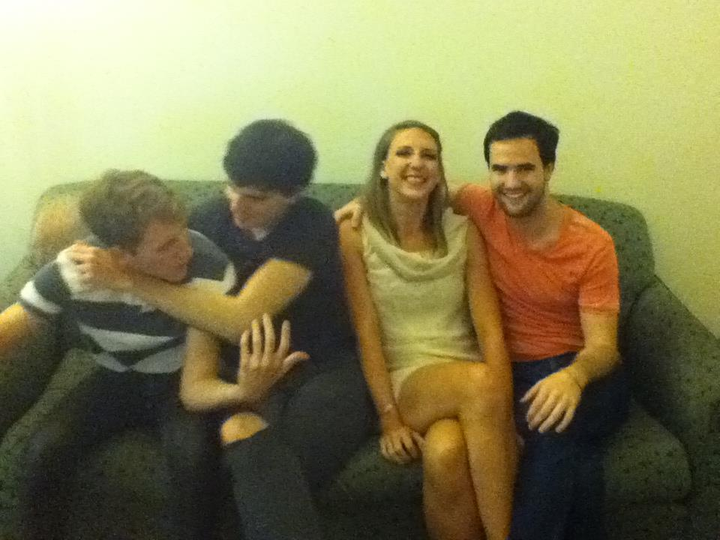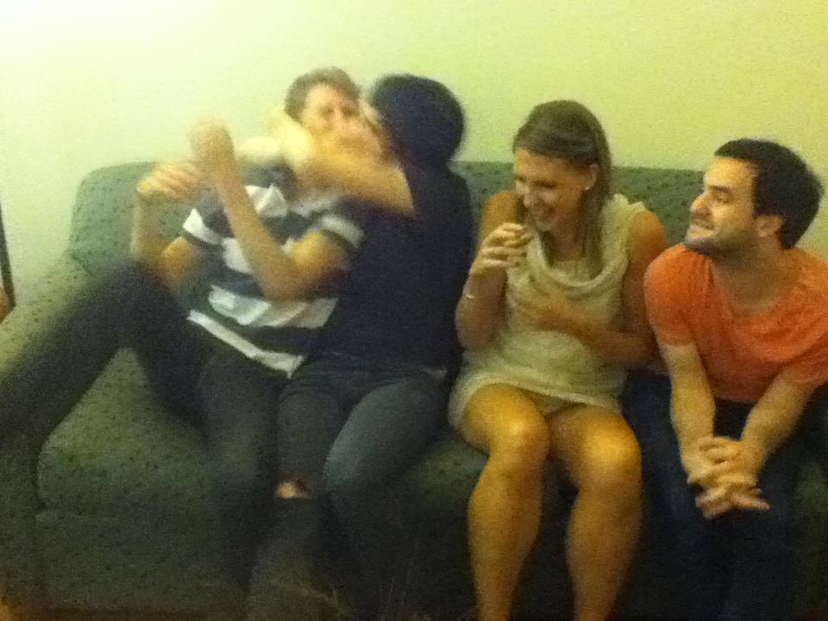

Crowd to See
a crowd of fifty—
fifty cell phone cameras—
raised like swaying lighters
at a live rock ballad—
jockeying to snap The Smile.
I was there—somewhere—too—once.

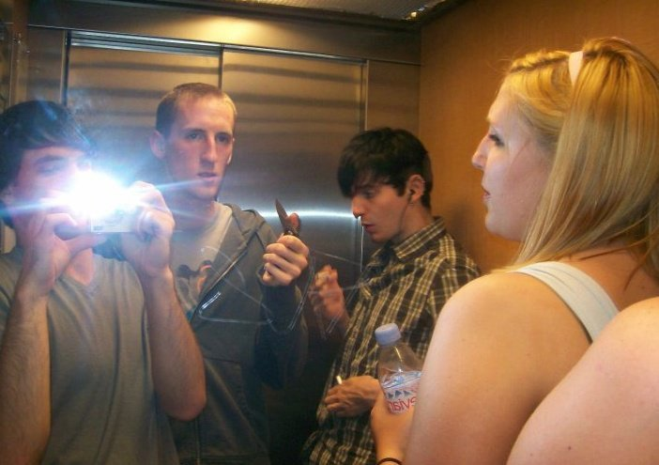
We laughed at bringing the knife around. “In case we get mugged.”
And then the night Alli got punched I wasn’t there anyway.

Sophomore Year
Undreams
We were college students on the floor of an apartment, passing bottles of wine between us and taking bong hits in the bathroom so the fan would keep her roommates from smelling us. The African imitations of Graceland grew out of a yard sale record player and flowered in the incense smoke about our heads. We told riddles and watched bad cartoons and inhaled each other’s laughter. After Paris, the onset of each night seemed reason enough for the four of us to huddle away and drink.
We commiserated in our sorrow, insulated, always feeling more damaged than we actually were, wallowing in a manufactured pain that offered more pleasure than sense. We lived a fauxhemian life, discarding our gifts and treasures to revel in our prolonged sadness. Our house of cards was founded on hypocrisy.
We kept a running joke that one of us could get famous. We imagined one of our exes picking up our book on the New Release rack of a bookstore chain and turning it over in her hands to read the back cover. She would flip through the pages and know that one of the stories was about her and she would buy the book with cash. She would go back to her apartment and sit in a chair with a drink and our book and think about us for the rest of the night.
Our hopes never stretched much further than that.

On a night in early spring, when the snow’s transience is finally revealed, we are locked away, playing Irish Poker on Bryn’s bedroom floor in front of her television. Our deck is incomplete, each card marred with a burn, a tear, or a wrinkle. Spilling on the carpet no longer worries us. We smoke cigarettes guiltily on the balcony in between games. Looney Tunes re-runs quip technicolor jokes so grossly passé that they’re touching. We are sitting in a square, the four of us, each with a bottle of wine at our right hand.
I am high, and drunk, and in love with my misery. I let the incense burn the corners of my eyes until my friends are as cartoonish as the characters on television. Adam is a black toupee atop a blue colored pencil. Stuart is a charred matchstick turning slowly to ash. Bryn is a red BIC lighter held aflame by an unseen hand. We are flippantly melodramatic; we are hot coals in a smoky room.
When my senses start to run together like a five-paint watercolor, and I can hear the television in their eyes and I don’t know if mine are open—I feel like in that dream I have, when the smiling canary finds me, binds me, and drags me to eternal, untouched forests where she releases me, and whispers, in my ear, in song, the names of all the withered trees who live on silver sunbeams—and I can hear the music of dead majesty. Or maybe I half-dozed while Tweety wondered audibly if he taw a putty tat. Or maybe it’s just Bryn, and I am wakened by our groaning, “T.M.I., T.M.I.” while she giggles.
Or maybe we all dreamt together, some unarticulated kinship bundling us like kindling to toss on one fraternal fire. I could have almost wept for the hope of communion but, why then, the sadness in our conscious eyes and unemphatic molestation of the void? And why do we believe in lies?
The door invades our reverie.
Like that, her lover of the month has entered, is in the room with one more joint, for two. We are, in silent intimation, quickly ushered out, moping through the flicker of a solitary wick, past the bolted doors of long-gone roommates, and out a softly closing door.
Outside, a parking lot, and trees. The tendril breaths of a setting mist grab our wrists and pull us into the cold, heartless night.

Superman

I am a star sailor
I was born of the man in the moon
I pull on the tails of comets
I blow smoke rings with Saturn
I am exiled with Pluto
I hover above your troposphere and
I watch you dig deep graves
Where the dead play fetch with worms.

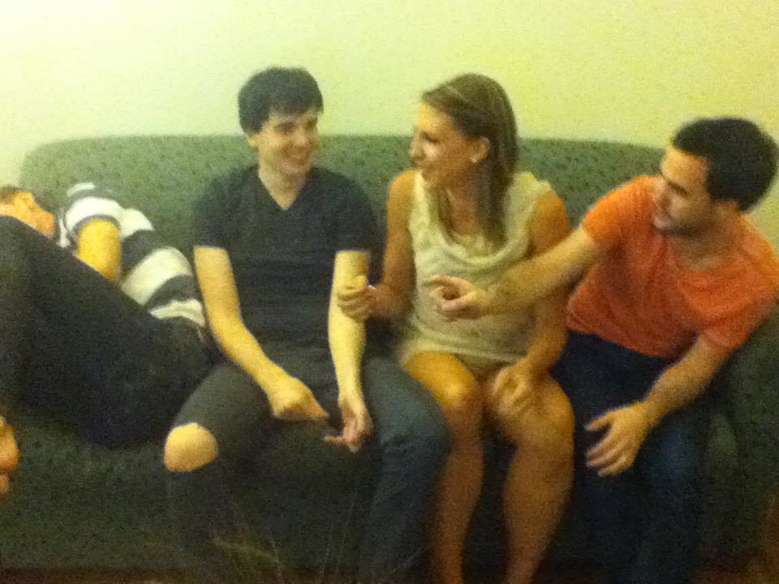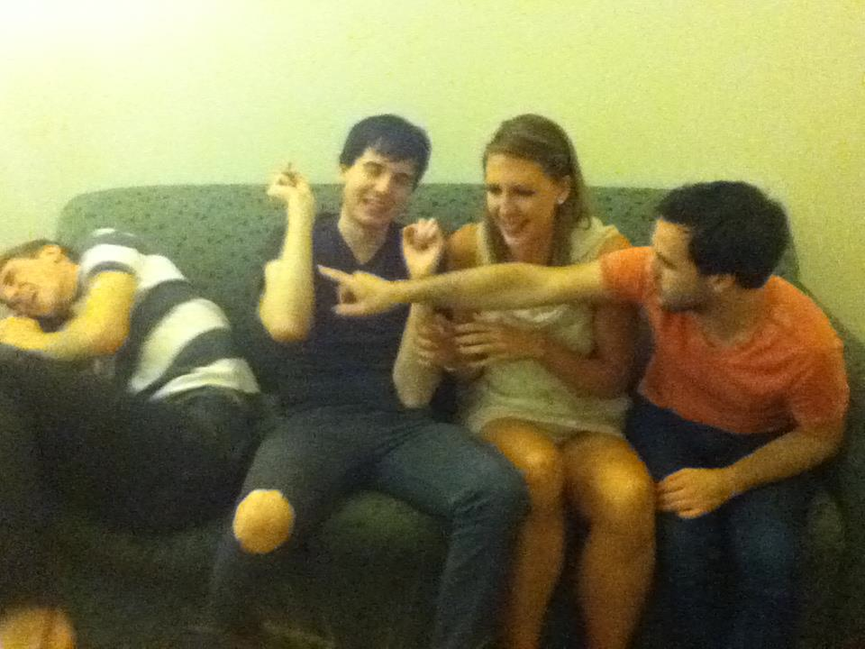

Unimportant Pocket Notebook Thought #8:
Crumble to dust. Dissipate.

A Taste of the Infinite
I’m aware that even sober I’m having trouble focusing my mind, and that I am hopeless at organizing it. My former therapist would say it is because I have un-medicated mental instabilities. David would say it is because I have self-medicated mental instabilities. And they’re both probably right. But in either case, it’s a change for my typically lucid, intellectual self.
This semester, I’m falling down the rabbit hole of my own thoughts, swallowed up in a dedication to question every truth I know.
I cling to a single phrase that seems to justify me: you have to give up control over your mind if you want it to take you somewhere new.
If only I can recapture some of the places my out-of-control mind has gone this semester, I may just have a shot at figuring out where I’m headed.
*
Chad, David and I stand around the low table, our heads bent over it, staring at the pizza. It’s Friday afternoon. I wonder aloud if the door is locked, and David tells me it is. Sunlight blares through the window, illuminating the haze of incense and marijuana smoke, falling on the golden cheese of the pizza.
I ask Chad if he is ready, and he says yes. For another minute we look at the pizza, covered in what looks like the chopped-up bits of white, brown and blue twigs. Then we start eating.
David tells us to have fun.
I look at him—skinny jeans, plaid button-down, one eyebrow raised under the wave of his jet-black part. Is he judging us? Do I care? Yes, yes. Oh, well.
I plan to, I say.
*
Chad and I stand on the top of a building to stare at the stars while we smoke. The back of his sweatshirt against the stained concrete, a flickering wall-light to his right illuminates half of his tall, black body. From a bird’s-eye view I see a ying-yang, my white skin in the night opposite the wall-light’s illumination of his darkness, the picture outlined by the globe of our conversation. I’m six feet tall but I have to look up to speak to him.
I feel like I’ve been having a constant out-of-body experience, I say. Like I’m getting so close to completely separating my mind from my body that I’m almost looking at myself from a third-person perspective.
This could be any night of the semester. We’ve re-hashed the finer points of this discussion more than twice, always here, on the rooftop.
Yeah. I think that’s what we’ve been trying to get to, right?
Kind of, except instead of getting to understanding it’s driving me crazy. It’s like trying to analyze your mind as if it were a book, reading it over and over again until you can know and understand every bit of it.
Complete self-awareness.
But it’s impossible, I say. Unless you can freeze time. Otherwise you set the book down in front of you to gather your perspective, but every time you start reading it, it gets longer. Every thought you have trying to understand it creates another thought to analyze. Not to mention the inability to recover awareness of your subconscious.
Chad observes my frustration, says nothing. I shrug. I don’t know, I say. Chad throws up his hood.
Personally I just don’t try to force it anymore, he says. I think my whole life is leading up to this moment that I can’t foresee yet. Maybe enlightenment or self-awareness or something. I don’t know what it is yet or how I’ll get there but I just have this pull toward the future, I know it’ll happen eventually, so I just let it go and wait.
Still, I say. I want to know what’s coming. What we’re searching for.
Chad pulls, shrugs.
Death, probably, I say.
Chad exhales, looks up to the stars.
When we descend from our loft and walk back to campus we pass Goggin. We stop in front of it, staring. The lights are all on, but there is no one inside.
Wonder, he says. He means it in the ancient Greek sense of the word, the same sense of wonder we get looking at the stars and feeling small. It’s not wondrous to me, just artifice. For the first time I look at the black space around the building. It is nothing at all. A brick square, an attempt to order space, to light it up and make it ours.
I un-imagine it and it is gone. It is void now, my mind destroying it just the way someone else’s created it. When we walk up and touch the space it used to be, the bricks leave white scratches on my fingertips. It will always be there. The ice rink is so empty.
*
At the beginning of each class we move our desks into a conference-table arrangement. The lights are so bright, there is no hiding in our circle. Our professor stands at the board, drawing words and pictures, defining signifier and signified. She draws a web of word associations, defining the misunderstandings inherent in language.
I draw my own web of understanding. Truth to reality to enlightenment. Conscious to subconscious to ontology to duality to immortality. Sex to perception to innocence to truth. Mind to meaning to connection to truth. Tack on wonder, artifice.
Cut that shit out, dude. I look at David, who is looking from me to my notebook and back. You think too much.
I look back to my paper. Deconstructionists drowning in alphabet soup, I write. David rolls his eyes, but I like that word, deconstruction. Creating something by taking it apart. That’s not what it means, I don’t think. But I like it that way.
David and I are walking to our next class, and he tells me again, you think too much.
It’s really hot outside, in my opinion. The end of summer, trees still green, but preparing for death. Feels like the hottest day we’ve had all year.
You’re not grounded at all. You’re up here all the time with these abstract ideas, you need to come back down to reality.
What if reality is that our language is fundamentally flawed and understanding anyone is impossible?
He admits it’s true to an extent, but I still have to play within the rules. I can’t lose sight of what’s actually going on.
The sun is really burning today. I feel warm and flushed. That is what’s going on. When I pass a big tree I look for thick, uncrowded branches and involuntarily imagine my body swinging from them on the end of a noose. I tell David he’s right. I am in wonder over all the ways I might be misunderstanding the signification of my subconscious projections.
*
The pizza is gone, and Alli has just arrived, responding to an invitation from David to stop by. The four of us sit around the low wooden table in the sparse living room of David’s apartment. There are two water bottles and a red Powerade on the table, all still half full. The lamplight cuts through the liquids, refracts itself on the wood in bands, two white, one red.
Alli is telling David about her fiancé while pouring glasses of wine for them. I am staring at the ceiling, afraid of the water sprinkler. It is directly in front of me but across the room and so high up, red and chrome and powerful.
Have you had sex with him yet?
All that potential power hanging over our heads, the ability to destroy our conversations with an irreversible and momentary spark.
Last night, for the first time. It was the most passionate experience I’ve ever had.
I try to ignore the water sprinkler and focus on the table. The red glare of the Powerade is unsettling and quietly enraging.
Afterwards, when we were lying in bed, I told him I wanted to forget the plan and get married tomorrow. And he said he felt like he already was married.
I get up, empty out the Powerade, refill the bottle a third of the way with water, and set it back on the table. Alli looks at me. Bad vibe, I say. By all means, continue.
We were both basically crying. God, it was so, so—
Intimate?
She says yes, exactly, it’s pretty surreal. We all nod.
It’s unlike me, but I find myself dwelling on what Alli had experienced. I’m jealous, pining. I fumble with my phone—it’s hard to make out the screen—and text Renee, my on-again, off-again, who attends a college upstate. I ask her if she’s busy tomorrow night. Message Sent—and I’m already doubting myself.
I’m going for a cigarette, I say. Chad and Alli join me, while David decides to stay.
*
I wake up feeling as though I didn’t sleep. Renee’s alarm is going off, and I am red-eyed and slightly hung-over. She tells me I can go back to sleep; she has to shower and straighten her hair for work. I let her climb over me and watch her walk out of the room. We slept together, but we didn’t sleep together. We are each other’s first. That moment is years behind us and conjures memories of the ugliness that followed between us, yet it is somehow inevitably pertinent, a lingering knowledge with which I have no idea what I am supposed to do.
It’s Sunday, which means the Bears play today, so while she is showering I pull a jersey and jeans out of my backpack and put them on. A tuft of my mohawk pokes out from a too-big baseball cap I wear backwards.
When she comes back from the bathroom she is dressed in black pants and a purple cardigan, her damp blonde hair hanging around her face. She begins the process of drying and straightening her hair, more time-consuming than I had ever imagined, even with her hair cut short. The rhythm of her hands moving around her head is quick and sure. I sit on the edge of her bed, watching.
She turns and asks me if her sweater is inappropriate for work. I blush with uncertainty. I tell her I don’t know, wondering if I can or should be looking. She turns back to her mirror and continues the quick snaps of her wrists. I am unbearably sad in the face of her professional surety.
I feel more estranged than ever, even though this is the first time I’ve seen her in the month since I came back to school. I cannot imagine her thoughts are anything other than getting ready for her first week at a new job, and yet my mind is trapped in my own web of understanding. All of a sudden I have no idea why Renee agreed to my visit. No idea why she wants to see me or why she wants to sleep with me or why she doesn’t want to sleep with me. I don’t understand anything about her.
Déjà vu. I am alone again. The alienation is altogether too familiar.
*
After we smoke I lead the way back into David’s apartment. As I sit down next to him he turns to me, shooting me his eyebrow-arch of judgment, and complains that we took a long time. Before he would have had time to turn his head back, he is sitting just as he was when I walked in. His mouth never opened, never said a word.
I ask him if he said something.
He tells me no, and he sounds confused or annoyed, which one, I’m not sure.
So I’m hallucinating, I say. Inquisitive looks prompt a brief attempt at explanation. The sober two roll their eyes and start talking about something else.
A subconscious projection of guilt, I muse. That’s what the mushrooms do, I realize; heighten awareness of the subconscious. The hyper-awareness is sometimes overwhelming, sometimes exciting. It is a taste of the infinite breadth of my own mind, a crumbling of the boundaries of thought.
Would my guilt have been any less real if I hadn’t been aware of it? My question interrupts their conversation. They all look at me, three big, round, cartoon faces. Doesn’t it still have power over me even when it’s not manifest in my consciousness?
David tells me I’m not making any sense. I’m tripping out.
I know, I say. Forget it.
He says the conversation they’re having is about God. And would I like to offer any thoughts on God?
Damn, dude. I can’t even get past the red Powerade. How am I supposed to talk about the fucking water sprinkler?
*
I am opening up a blank word document and typing the words I have been mulling for weeks. I am writing out nonsense about mushrooms and buildings and understanding and sex and leaving so much more nonsense out.
I am writing this very sentence, right now. I am realizing what this semester has already taught me.
My mind is not an essay, or a book, or anything I can hope to read or control. The truth of my reality is malleable and ultimately unperceivable. Words are too subjective to facilitate adequately objective communication. God isn’t worth the trouble.
What I now understand is that I don’t understand anything, least of all myself. But I would rather be truly aware of my ignorance than ignorant in false awareness.

How I Learned What Love Is: One

I fell in love with a girl named Sydney before I even really knew her and took LSD with my friend on Halloween and she showed up and I was in utter shambles so I “left to get a pack of cigarettes” and went back to my dorm room and turned my phone off and my roommate was gone for the weekend so I stripped naked and hated myself in the mirror and got into bed and laid there sweating and gnawing on my mind until I was sane enough to watch The Big Lebowski and couldn’t fall asleep until morning.

Unimportant Pocket Notebook Thought #9:
I fell asleep with my glasses on and woke to
find they no longer fit my face. I squashed
them with my dreams.

Formal with a Friend

There was a moment
after we danced
before we left
when we both laughed
and I guided your head
to my chest
without you
resisting. It felt more
natural
than it should have.

In your room
on your bed
my eyelids heavy
as guilt
I touched your
knee

earlier
dancing
to just the slow
sad songs
I like
was the closest we’d
been.

Relax.
I could have kept my nose
in your hair forever
if
it didn’t expose my
sin

hungover from the
day and night before
when I drank
tequila in the sun
drained from the
night a week before
when I fucked
an old friend in her bed
it was so easy to sleep

on your floor
cold
alone
beneath
you in your bed
under your comforter
surrounded
by walls of index cards
and sticky notes
on which you’d
written psalms.

I imagined that
would be the way we
both
would die.

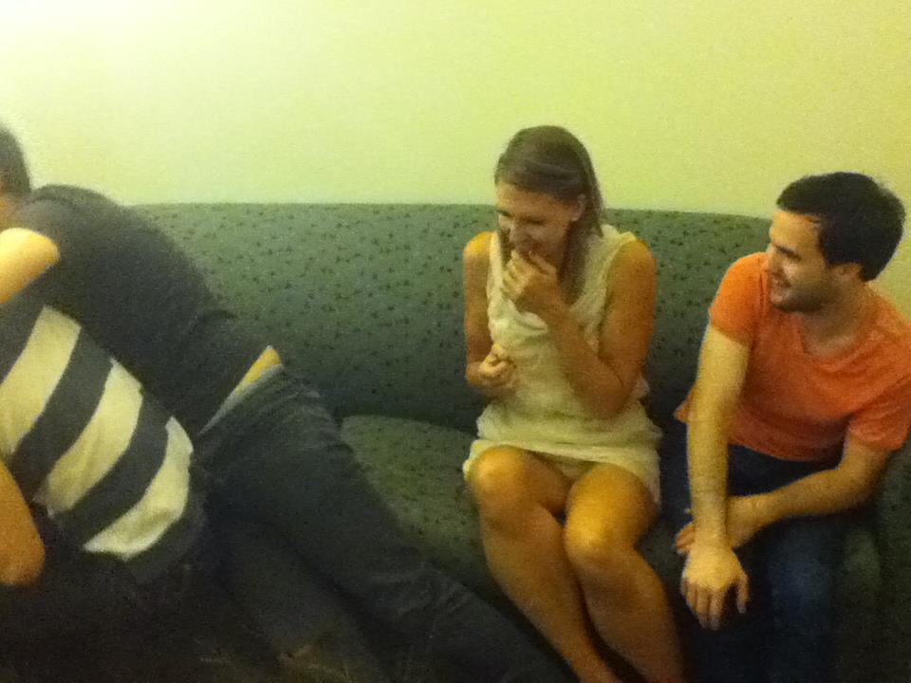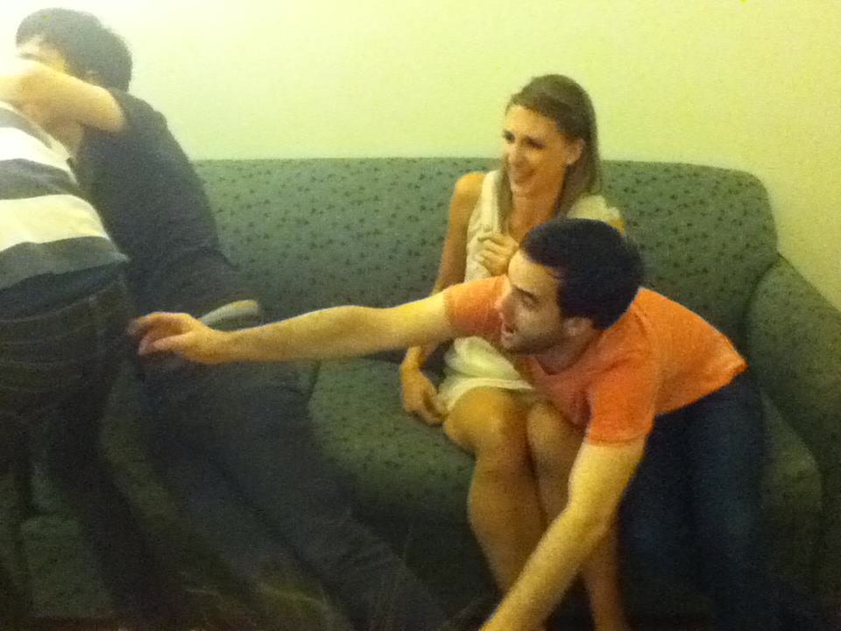

Sydney
Pigeon

I was eating eggs
And bacon alone
With the hum of the
Big Refrigerator
In the Big Kitchen
That all the tenants use
But never clean
Except, I think, for me.
(It’s not sanctimony
But a fear of filth.)
Up by that rafter
There’s a slim white fluttering
Of plastic, I guess,
Or insulation, but thinner,
Like a bobbing tail
Or a pennant.
I wonder if I’ll ever leave the city
And live in quietude again
And naturally that
Leads me to wonder
Why I left.
I’m interrupted
By my tongue which
Registers ‘my food
Tastes like Teflon.’
I blame:
My shabby cooking skills and
My degenerative frying pan.
But what else can I expect for
Fifteen Australian dollars and
One suburban childhood?

Salvation

Don’t you think you’re silly?
like at all? or even sometimes?
or can you not see?
that something in your
countenance is hard to take
seriously? like
maybe it’s those dull green eyes?
or unwashed hair?
or crackling quiet voice?
you use when you talk to
yourself?
when you’re alone? or even
walking down the street? I
saw you doing it
the other day you know
or no I know
it’s probably the way you
read that poetry out loud
at night
to yourself
when you can’t fall asleep you
know it keeps your neighbors up
they can hear you through
their walls
but maybe just
can’t make out
the words like
I am a silly seesaw of emotion!
and words are salvation!

I Hate That Fucking Frying Pan

The plastered egg whites
Smell and are tenacious,
Even against water pressure.
They are like man.
I cannot remove the eggy caulk
From any surface.
I try to remove it with the soft side
And then the tough side
Of the sponge but I guess
That damages the Face.
With every use that fucking
Frying pan melts into my food
And makes me ill.

Unimportant Pocket Notebook Thought #10:
Sometimes, my bed is so big, I don’t know
which side I am lying on, or if I am lying
straight or on a diagonal. But I have a
window.

Unimportant Pocket Notebook Thought #11:
My medieval lit professor wears a silver
snake ring.

So Quick to Linger
I had been at the beach all day, reading, when the fang-eyed brunette I left the States to get away from stepped out of the ocean and strode straight toward me. She was carrying a rolled-up towel and a beach bag. When she appeared I was sitting cross-legged on my towel with a book in my lap. I raised the book up to the bridge of my sunburnt nose and peered at her as she walked with her stare leveled somewhere beyond me.
A silver ring between her breasts connected the two halves of her black bikini top. She marched through the sand just to my right, and for a second I thought she might pass right by. But instead, as soon as she got beside me she turned around and laid out her towel, sopping wet with seawater. Then she laid out on her back to tan and closed her eyes.
I could have run. You don’t need to tell me—I know it. I should have. Right then, I could have grabbed my towel and booked it down the streets she didn’t know, or I could have inched away, lifted up my chafing ass just barely off the ground and slowly crab-walked out of there, freezing, if she tried to peek, like I were her prey. I could have snuck off without a sound like just another grain of sand blown sideways in the breeze.
But I didn’t. Instead, the fool I am, so quick to linger, peered sideways over the text I still held pressed against my nose as if it were some real defense. And once I peeked, I couldn’t help but gawk.
Her hair was shorter now, the shoulder-length strands dark with moisture, and the cut made her look like a renegade princess, like dignity’s day off—a refined beauty embracing her carnality. The nose I’d kissed ten hundred times tipped upward to the sun. The contented grace of her sleeping lips almost made me love her again—before she parted them to ask me if we were staying in the bay for dinner. She was hungry, she said.
“Crossing oceans is hard work,” she said. She held out her hand. “Just look at how pruny my fingers are,” she said, all the while her eyes pinned shut against the sun.
I let my book down. We may as well have been in bed again, in the way we had been, in the way we wasted years on end. My very own siren, my mermaid mistress, come back to haunt me with the same old song.
“Shut up,” I said, and left her hand dangling, suspended between us. “I want to finish this book before the sun goes down. It’s exciting. And loyal.” She didn’t turn her head, didn’t even raise an eyebrow, just pretended like she had never heard my hurt.
“You know I don’t like Thai or seafood, so we’ll have to go somewhere more neutral.” There was an Italian place just a couple blocks down, but it was overpriced. Plenty of ice cream spots along the boardwalk, a few bar and grills, I was pretty sure.
“No, Jess. I’m not taking you anywhere. I’m not going with you.” I pulled my gaze off her and forced my face back into my novel. I pulled my hand out of hers. “I didn’t even know it was possible for skin to get that wrinkled,” I said.
She reached into her bag and pulled out a bottle of tanning lotion with a strand of seaweed wrapped around it.
“Do you mind rubbing this in for me?” She rolled over onto her stomach. She undid her bikini clasp. She peeled off the seaweed and held the bottle up, knowing full well, I’m sure, the bare skin she revealed to me.
“No. Absolutely not.” I thought of my book, the characters waiting, paused in action. “I don’t want to go down this road again.”
She opened her eyes and looked at me. They were soft and ferocious and cunning and honest. They stared into my mind and rifled through it like they owned me, pulling out and shoving in my face the memories of morning stare-downs over the rising steam of coffee mugs whose black aftertaste still sat bitter under my tongue.
“Still the same old you, I see,” she said. “You’re too sweet. Too afraid, too soft natured. Your intentions are too good. Take a risk.”
“There’s no risk here, Jess. It’s a bad decision that I’ve made before. I know the ending of this story and it’s not a happy one.” Her back was warm under my fingers, and smoothing the oil onto her nape, straddling her, I was aroused.
“Kiss my ear,” she urged with a moan.
“No,” I said, and ran my tongue up the outside from lobe to top. “I’m still not taking you to dinner,” I said, and before the sun was done we were running up the beach to rinse our feet, the promise of marinara on our mind.
I asked for a table for two. I hated the power of the past. I loved the smell of watermelon shampoo. I wondered how to finally escape her, and reached across the table for her hand. I missed her. I hated her.
Over waffle cones I asked how long she would be staying, and her eyes smiled.
“I knew you’d take me back. I knew you’d remember there’s no end to us.”
Under the weight of her finality, I damned myself for settling for the curves that burned me every time I woke without them, every time she strayed. Damned myself for needing familiarity, at least until an again. Damned myself to her pretty company until the rhythmic waves washed one of us away again.
I strolled along the beach and let myself smile back, her kiss warm on my cheek.

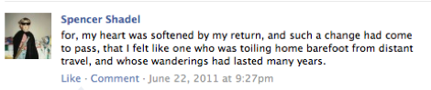

-summer-

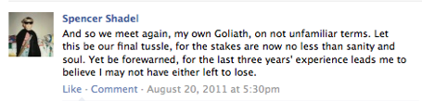


Senior Year
The Cynic’s Penultimate Semester
I am in Oxford, but not in England. I am at Miami, but not in Florida. I am the red and white of the Redhawk, the red of the skin of the men from whom we stole this land and the white of the skin of the thieves. I am the red and white of the blocks of faux colonial brick with their white plaster pillars, the three-street maze of patterned mimicry that constitutes this mirror world. I am the green of the sprinklered, landscaped quads and the yellow and green of the seas of corn that pen in my island world for miles upon uncountable miles. I am as short as the three-story buildings that, by law, cannot be taller; and I am as tall as the twin bell towers that sing to each other, sending their chimes over the rooftops in a quarter-hourly display of unfalteringly prompt intimacy.
I am the unspoken uniform—the straight hair, tan face, North Face, black tight, Ugg boot, Longchamps girl; the minor variations of a major frat theme boy; the white, white, white skin with its bursting wallet and dumbed mind.
I am the sneer of refusal, of distaste and high taste, of the superiority of a fake I.D. in my back pocket and a father’s cash. I am rudeness because I can be. I am a sybaritic dogma of Machiavellian individualism. I am Christianity without a why, and only when I want to be. I am the taste of sweaty lips or stick of dancer’s pole, I am morning come too early, I am secret drugs and secret rape and never, never eat.
I am also sociable and amiable, conversational and sweet. I am persuasively gentle-hearted, capably intelligent, proudly ambitious. I am success. I am low standards, I am beautiful. I am back-turned scoffs, I am spotlight smart, I am aggressively brandished drinking.
Mostly, though, I am none of these. I am the black-clothed rejection of my world, I am skeleton puppet silliness, I am existential angst, I am solipsism justified, and I am empty where identity should be.
I am give me one compassionate being to fill my void. I am want of television for infant library. I am purposelessness mocked by hedonism, the search amid a world renouncing search. I am why, I am why, I am sceptical romantic, I am dead humanism. I am sense perceived nonsense, loathing perceived loathing, sensitive perceived gay, nothingness perceived shallowness. I am difficulty amid ease, I am pensive amid celebration, I am mirror for your fear.
I am freedom of a sense you cannot know, as you are of me. I am guilty, you are guiltless. I am shameful, you are proud. I am let me count the ways, and you are you are the weakest link. I am vain in mind, and you are vain in body. I am scribbling droopy longing fictions of love, you are making it. I am abstinent, you are honest.
I am godless, you are god. You are thorny black rose bouquet, I am drowning, I am submerged creek stone gurgled over. I am smoking coffee addict, you are gym-toned workout warrior. I am bookpage white, you are sun pool tan.

I am your secrets dark, unspoken, unthought.
I am your daddy works for my daddy.

I am wondering—can’t you see how similar we are? How little there is to like in each of us?

The Kiln

it was worked too thin,
the matter smeared on your finger
tips, on paper towels in waste bins.
you let your hands linger for
too many days, the lighter hue
of a hole-to-be in the material.
you, grabbing it from her, and him,
grabbing it from you, all kinds
of prints worked down the clay
when one would have done
just fine. the only oven
needed was the sun.

when vases turn to torches,
joy becomes a fuel. tattoo

the face of vases, fly like swans
to shriek the name of freedom
to the clay they lay their eggs in;
into the hot mouth
that speaks and spits with
unblinking silence

30 vases fired
in sleeping flower ovens
to the tastes of kiln of
needless forming burning
up the dreams of sleeping tulips
for the brittle hardened rest—
he who lights the fire burns
Bukowski’s epiphanic
poetry at last

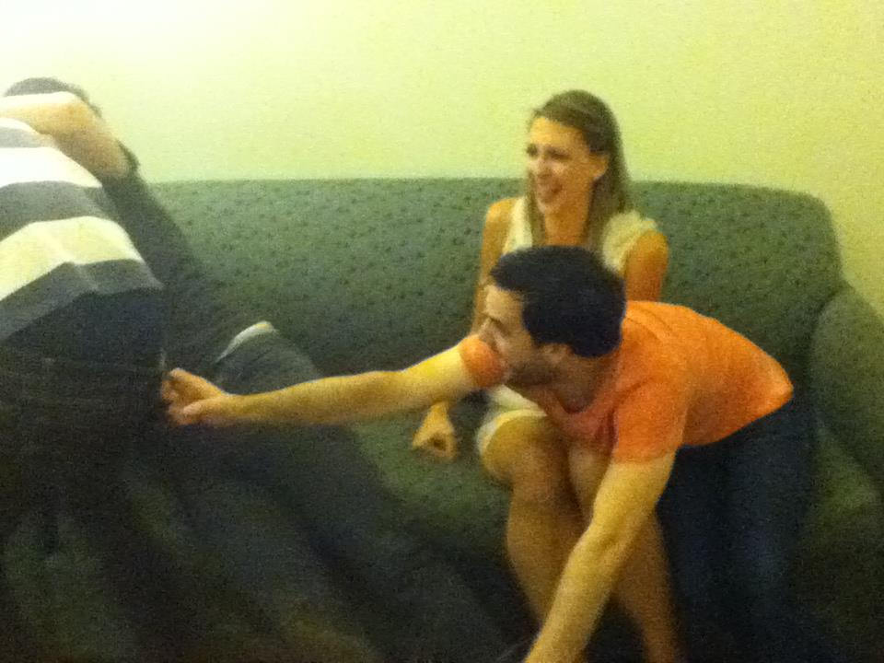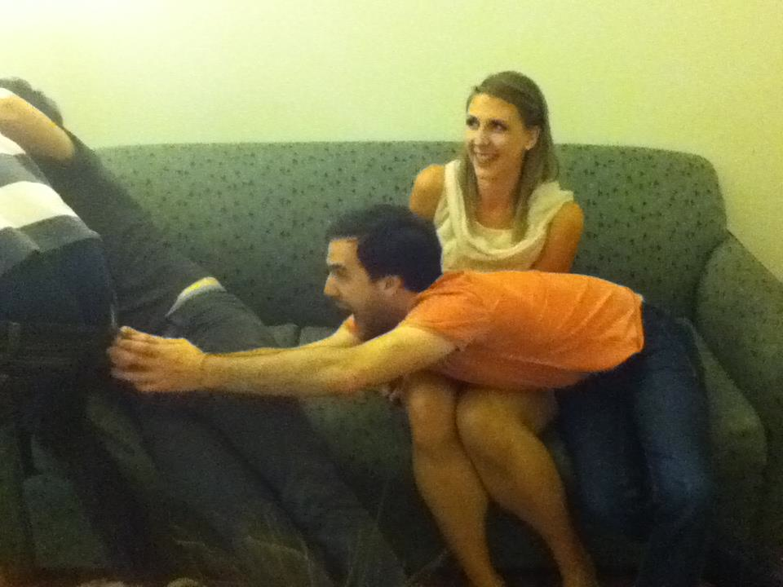
Shoeless Indian Summer

Shoeless Indian summer
Faulkner and Pound in the
Scratchy grass sitting
Cross-legged Indian-style
Under this cloudless
Hemisphere—blue—
The burning generosity—
Nature’s death flourish—
Che spitting grandiose
Zeal on his killer’s face.
My roommate in
The warmth the crisp
Fall is flying to
Ten thousand feet to jump
Into the embrace of that
Palette of autumnal fire.
For love of Earth and beauty
He does not fear to die.
I am me, eating spicy
Nuts and Cajun sticks
In the blazing plains sun
Until my nose sweats blood,
Reading while the world turns.

Unimportant Pocket Notebook Thought #12:
You’ll never find a lover in your cellar.

How I Learned What Love Is: Two

The next time I took LSD it was on Halloween again but I was with my big brother and my little sister who’s hardly little in any sense except stature and one of my closest friends Brian who’s basically a brother and we played Nintendo and party hopped for six hours so uncomfortably self-aware and played with kittens and accidentally fucked up my sister’s plans because we needed pizza and to stop walking but I even liked the rain.

Posed to Profession

a black coat drying on a chair back
an empty bottle of merlot flank
a busy processor atop
a desk of books and pens:
the accoutrements of a career, sans la vivre

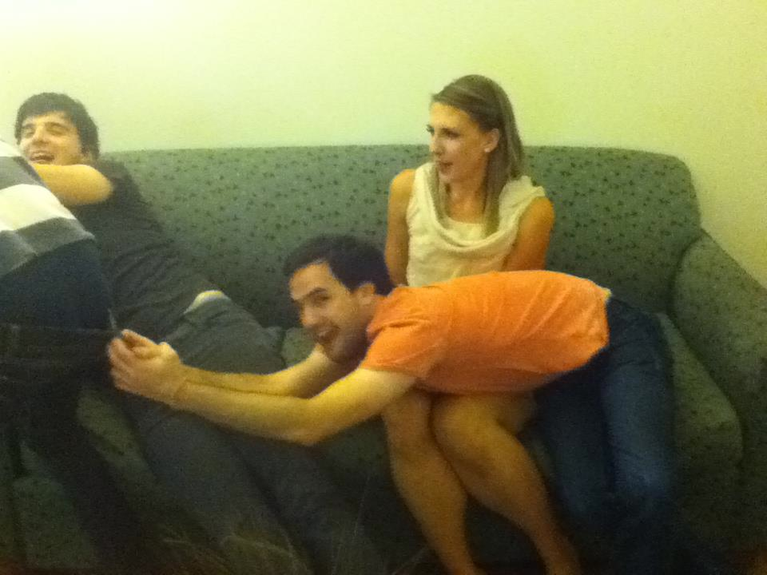

Unimportant Pocket Notebook Thought #13:
Your life is mired in the prison of your thoughts

I was driving the Miata down Chestnut, away from Patterson, on a rainy day. I took a hard right onto Maple and the back end slipped a touch before I caught it. As soon as I straightened out, I saw an explosion. At first it was ambiguous, what I had seen. There were no other drivers, just parked cars and this explosion right on the yellow lines. I kept driving towards it. I saw a semi or a large pickup, and a motorcycle fly off the trailer or the bed and onto another car. Cars were catching fire. The drivers seemed to be scrambling around, trying to put it out or get away. Then a larger explosion—large explosive drums, or a gas tank, caught fire and blew debris tens of yards into the air. I stopped my car, pulling over to the right side of the road. I was readying myself to go help, to yell that ‘I’m an EMT’ and administer First Aid to anyone who might be left. Then, I was parked, still a few hundred meters away, and an underground pipe close to the fire bursts. Right at the edge of the street, apparently having been racked by the explosion, a geyser of water shot into the air from this busted pipe. About this point I was lucid—I knew the pretense of the world—and part of my consciousness wrestled for control in vain. The geyser set off a chain reaction, and jets of water began shooting up every five feet or so, following the line of the street, heading right at my parked car. I fumbled with the seat belt and the door latch as the geysers approached too quickly. I tried to will myself out of the car, imagining myself running away from it, but didn’t make it in time. I woke up as a geyser erupted directly beneath me, wondering why I hadn’t just driven away.

Unimportant Pocket Notebook Thought #14:
I’m wary of things that sparkle, especially
rhinestones and women’s eyes.

Writing for Beginners

In the beginning, it was a steady outpouring of emotion and self, sometimes because the emotional urge was too much, became a need, consumed by tension until expressed, a nonsense purge, followed by the immediate relief and then for ever after the shame, but usually because someone made you.
Some anomalies, like when I was seven I typed up a word-for-word copy of my edition of Le Morte d’Arthur, which was some kind of need but not an outpouring, just a thrilled celebration of obsession.
But mostly not, mostly this kind of forced outpouring which I was good at because
- because I’m honest
- because I’m good at appealing to authority. The easiest way to get to know how to relate to your audience: get a big brother, watch his mistakes, and then learn what they want instead. So when my teachers asked me to write something, I knew what they wanted to see. Usually it’s what my parents wanted to see. But either case I had an hour a day with them and 20 other kids. Plenty of opporunities to watch someone make the mistake first.
That’s why all those essays you see,
college essays
Chicken Soup for the Soul
my-mom-had-cancer-and-I-learned-this-life-lesson essays, or I-went-on-a-mission-trip-and-saw-poor-people-and-now- I-have-Christian-sympathy essays
are so cut and dry formulaic. Their audience is Authority.
The need to please.
Then come the ‘I want you to write about what you want to write about’ professors—they’re usually professors—who refuse to enforce a direction, only “good writing.” So then you have ‘no’ audience and a confused inspiration.
If you can’t be mad or
critical then I can’t
read you and
if I can’t
read you I don’t know how to write to you and if I
write to you and I don’t know how then how can I count on pleasing you
I want my A I want my pat on the head
just as much as
I don’t want anything from you
and mostly I don’t know what I want
to write about so fuck
it’s a cycle of self-loathing and frustration and disappointment with shards of hope
At which point you start to try to listen to their tips for good writing and then writing becomes rules for thinking
thought rules
ideological processes or
is that what I mean what I mean is
Use higher level diction. Don’t philosophize! Don’t even think! Don’t use clichés. Be original. Be the pen. Be the paper. Don’t use a computer! Use a computer! Don’t pay attention to the spelling or the grammar. Don’t write for anyone but yourself. Write with your audience in mind. Don’t describe. Don’t express. Write honestly. Write from your heart. Don’t be melodramatic. Don’t be sappy. Don’t use exclamation points! Don’t use semicolons. Use unique images. Use what you know. Don’t write about what you know! Write MORE. Don’t be boring. Don’t write about being boring. Write in form. Write in language. Write in sound. Write without thinking. Use that other part of your brain—no, the other part, your other left. Write from the subconscious. Be concise. Be clear. Elucidate briefly. Be specific. Know when to end. Know when to keep going. Create tension. Create beauty. Create interest. Don’t pay any attention to anything else. Get in the groove. Let it just flow. Write every day. Practice. Do it anyway. Be detailed. Don’t throw it away. Don’t throw anything away. Don’t write about yourself. Don’t write about writing. Don’t be simple. Don’t be vague. You have to. You have to. You have to. You have to. You have to. You have to. You have to. You have to. You have to. You have to. You have to. You have to. You have to. You have to. You have to. You have to. Just write. Just right.

And then you realize
fuck it I’m not good anyway so who really cares
So then you have a stream of shit that sucks and that’s really all;
sometimes you get really honest and so it’s not horse shit but it’s still shit—
you’ve stopped kidding yourself.
Every rare once in a blue never you create something almost beautiful and I’m not going to try to force one out right here to prove it to you or anything but I do wish one would just come naturally.

Untitled
(A Ghazal)

when am i not sealed up in a wooden box? at a white-washed
three-walled desk, under drop panels and rafters. when i’m laid to rest

i don’t believe i’m going anywhere else. unless i stowaway
america, u of will be the place where i disintegrate to worm meal.

the sniveling nature of the suburbanites infects me until i whine too i
i can’t even admit to my macbook that i’m horrible too, that my nature

is human nature, that i am horribly human. talk about the light:
fluorescent sheathes of don’t-fall-asleep (don’t say me or i again).

Ovid’s laughing from the top shelf, peering over my cubicle rim
it’s been said before, but i want to say ‘go away!’ i wouldn’t, i feel

i can’t, yell in a library, not even not in a library. america, u of kindly reminds us
to keep our voices down around our ankles (pick any word besides “shackles”)

to end this ghazal and turn it in and never force myself to read it again.
Ovid can live on and watch new juveniles die. i will do no such thing.

You And Me And The War of The End Times
(A Cento)

I. Had a Dream

I wake to sleep, and take my waking slow.
I climb through woods in the hour-before-dawn dark.
Evil air, a frost-making stillness.
After a time,
Standing above the noontide,
Above the bridgehead,
Between the streams and the red clouds, hearing curlews,
Hearing the horizons endure.
The smell of blood already floats in the lavender-mist of the afternoon.
A great fearful thing already tugs at the cables of the open air,
The drums of curfew pander to a dance of death;
Rays, violet and short, piercing the gloom,
Foreshadow the fire that is dreamed of.

I learn by going where I have to go.

Then the sun
Orange, red, red, erupted

Silently, and splitting to its core tore and flung cloud,
Shook the gulf open, showed blue.

What falls away is always. And is near.
What can death send me
That you have not?

II. I Have no Fear of Phantoms, But of The Real

over my sleeping self floated flaming symbols when
Something like living occurred, a movement
Out of the dream into its codification:

I awoke to my alarm clock
It was a pop song, it was playing loud:
I saw you vanish into air.

Awake,
i do not worry if briefer days grow briefest,
i do not worry if longer nights grow longest
I feel my fate in what I cannot fear.
I learn by going where I have to go.
I envy you your chance of death.

I just see
That I want it to go on, without

Anybody’s getting hurt, and for the shuffling
To resume between me and my side of night.

III. I Just See

Now I’m hunched over a typewriter
painting in a cave
I’m adding pressed flowers
until, after a time,
I have a good collection.
I am not a demigod,
I am not Prince Hamlet, nor was meant to be:
I cannot make it cohere.

Let those I love try to forgive
what I have made.

I learn by going where I have to go.

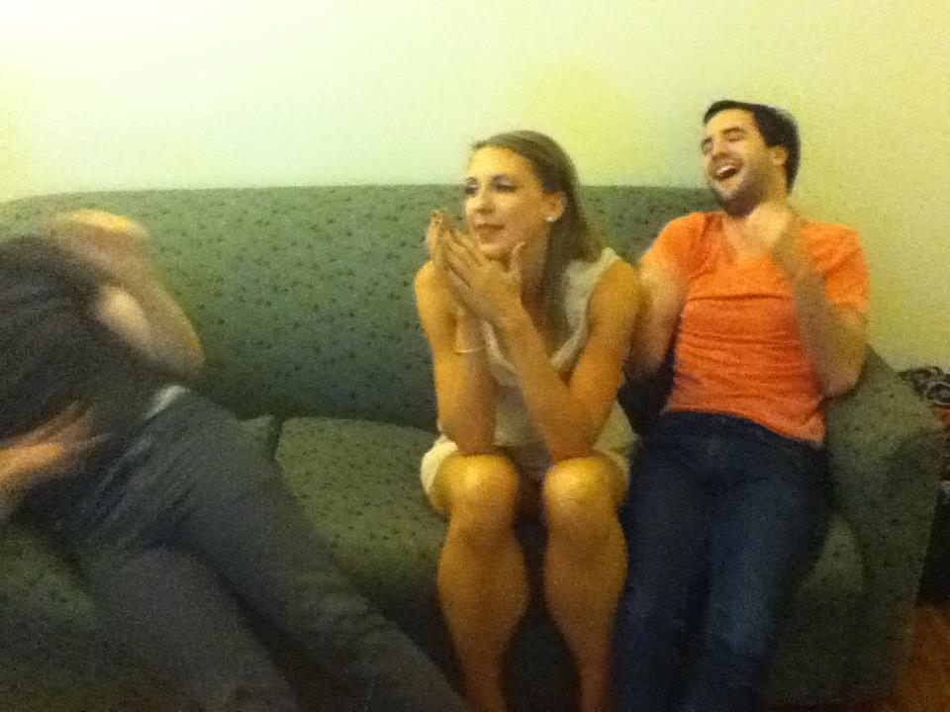

Unimportant Pocket Notebook Thought #15:
Where do we go from here?

