A Profile of KNM-ER 1813: The State of Early Homo from the Specimen’s Perspective

Nicole Schapker
24 April 2017
ATH 355
Word Count: 2175

Introduction
Since the search for hominid fossils came into full swing by the mid and late twentieth century, the amount of variation that continues to be uncovered has generated intense debate over the classification of our earliest ancestors. The evidence is fragmentary at best, and what is unearthed often only adds to the confusion. Specimen KNM-ER 1813, uncovered in 1973 in Koobi Fora, is a prime example of this, caught in the battle as one of the cornerstone specimens for possible splitters, lumpers, and reformers of the hominin phylogenetic trees. Today’s scientists must identify what is most important when partitioning these specimens: size, morphology, biogeography, and range of territory. The former two have been reinterpreted many times over in relation to KNM-ER 1813 and how one might define early or transitional Homo.
What, Where, and When?
KNM-ER 1813 was one of twenty specimens uncovered over the course of the 1972-1973 field season in Koobi Fora led by Richard Leakey (Leakey R. , 1974). The fossil is a fragmented cranium, consisting of most of the cranial vault, a rather prominent supraorbital torus, the right zygoma, and a mostly intact maxilla containing well-preserved left P³ to M³ and right M³ (see Figure 1). Its fragmented state meant that reconstruction was necessary, though its relative completeness made this easier than other cases, and no rearrangements of the fragments have been suggested. In this initial announcement, each of the twenty specimens were deemed some form of transitional Homo, still small-brained and prognathic though slightly more gracile than Australopithecines from before like A. afarensis or P. bosei. These remains were not found with any sort of tool, but if the assignment to H. habilis stands true (discussed below), then these creatures would have been using Oldowan tools, consisting of chopping tools of limited modification (Leakey, Tobias, & Napier, 1964).
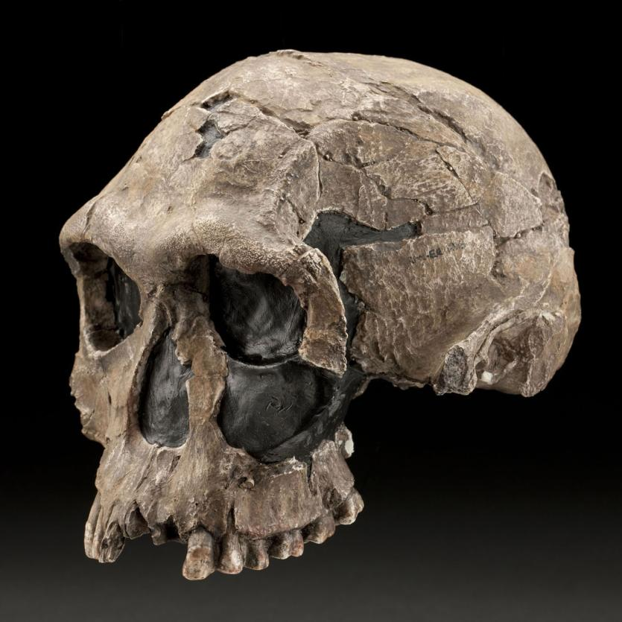
Koobi Fora is a field site to the east of Lake Turkana, formerly Lake Rudolf, and the territory is divided into different “areas” or dig sites of approximately the same age (Day, 1977). KNM-ER 1813 was found, for instance, in Area 123, further away from the lake (Leakey R. , 1974). The stratigraphy largely consists of sediment beds overlapped with volcanic tuffs, though uneven sedimentation has caused some difficulty in dating in the past (Feibel, Lepre, & Quinn, 2009). The field season that led to the discoveries were carried out in these different regions of Koobi Fora. Area 123 also yielded KNM-ER 1810, 1811, and 1812, though none were as complete (Leakey R. , 1974).
Figure 1. KNM-ER 1813 in Three-Quarter Profile. Image from Smithsonian Institute Human Origins Initiative
There has been some debate about the age of the fossils found at Area 123. The announcement article gave an uncertain stratigraphic assignment and positioned the fossil in the Lower Member of the Koobi Fora Formation, above the KBS tuff (Leakey R. , 1974, p. 654). A reanalysis of the stratigraphy later led Gathogo and Brown to believe that the fossils lie just on top of the KBS tuff, making them quite younger than initially thought (2006). The principle obstacle was that across Area 123, there is not even sedimentation; entire layers are missing from this area though they occur in nearby locales. But the reorganization of the stratigraphy would have significant consequences for KNM-ER 1813’s taxonomic classification, much of which revolved around its supposed contemporaneity with KNM-ER 1470. However, another revision was made, and using magnetostratigraphy, Feibel et al. were able to confirm the fossils were below the KBS tuff and were between 1.89 and 1.90 Ma (2009). This closed the gap between KNM-ER 1813 and KNM-ER 1470, a significant find to be discussed below.
Who and Why?
Outside the Genus Homo
Since its announcement, KNM-ER 1813 has been a puzzle because of its small size. Despite some initial comparisons to A. africanus and remarks about shared primitive features, Richard Leakey decided to put the fossil in Homo (1974). Before delving into the controversy surrounding KNM-ER 1813’s particular assignment in Homo, it is important to discuss the nature of early Homo in general. Those comparisons to A. africanus should be telling about the dubious nature of the older Homo specimens and their genus placement.
Before 1964, the oldest specimen attributed to Homo was that of erectus, which did not have old enough specimens to reach back 1.5 million years (Lewin, 1987). That year, however, an older fossil found in Olduvai Gorge was announced and proclaimed the type specimen of a new species, Homo habilis (Leakey, Tobias, & Napier, 1964). The name means “handy man” as the authors thought they had discovered the true craftsmen of the Oldowan tools; Homo would be the tool maker instead of Paranthropus, the robust Australopithecine contemporary. At the time, the announcement dropped the cranial capacity threshold characteristic of the Homo lineage from 750cc down to approximately 600cc and made early man surprisingly ape-like (Leakey, Tobias, & Napier, 1964; Lewin, 1987). The principle argument is that these specimens originally attributed to some form of early Homo should instead be relegated to Australopithecus, and this argument is largely based on a gradistic classification system instead of a cladistic one (Walker, 1976; Wood, 1992; Wood, 2016). When H. habilis was announced, it was thought to be the ancestral species to a group of taxa that would include modern man and as the root of the clade should be included in Homo. However, others have argued a gradistic classification is more appropriate, equating the word grade with genus, and letting the primitive Homo habilis sensu lato change to Australopithecus habilis sensu lato (Walker, 1976; Wood, 2016). For example, OH 62 or “Lucy’s child” was found in 1986 and was attributed to H. habilis, but analyses of its post-cranial remains suggest that it was engaging in both arboreal and terrestrial locomotion. (Johanson, et al., 1987; Lewin, 1987; Antón, 2012). The absence of obligate bipedalism constitutes the occupation of a different adaptive zone, or grade, and thereby genus.
Following these arguments, it remains plausible that KNM-ER 1813 could be part of Australopithecus rather than Homo. However, these gradistic arguments have still not gained much popularity, despite the fact the issues raised against the early Homo designation have persisted for at least 40 years now. The following discussion on KNM-ER 1813’s species placement will therefore continue to use the genus Homo with the understanding that the speciation arguments could still exist under the Australopithecus designation instead.
In the Genus Homo
Most of the discussion surrounding the species assignment for KNM-ER 1813 has centered around its difference to a specimen announced a year before its discovery, KNM-ER 1470 (Leakey R., 1973). It was found in nearby Area 131 of the Koobi Fora site and after a reanalysis of the stratigraphy was dated to around the same time as KNM-ER 1813 at 2.03 million years old (Antón, 2012); however, it had a much larger skull, originally estimated around 800cc (Leakey R., 1973). Ever since, there has been debate about how to portray these two specimens in an appropriate manner: Are they separate species or subspecies, or could they be evidence of significant sexual dimorphism in early Homo?
The two specimens have long been contrasted against each other because their relative completion and context of discovery have led many to question the early hominid taxonomy, and as such, each have also gone through a number of reassignments in paleoanthropological literature. When it was first announced, KNM-ER 1470 was declared Homo sp. indet because its cranial size and some relative gracility made it too human-like to be included in Australopithecus (Leakey R., 1973). In 1986, however, Valery Alexeev proposed the species H. rudolfensis based on some morphological differences and the size of its cranium, and since then has been the type specimen representing only a few other very fragmentary and very contested specimens (Antón, 2012). At the time of its announcement, KNM-ER 1813 was also Homo sp. indet. But based again on size differences, the authors suggested that KNM-ER 1470 could belong to H. habilis, and KNM-ER 1813 could represent a contemporary group that was separate from H. habilis, though no name was proposed yet (Leakey R., 1974). Some attempts were made to assign it to a completely new species, like H. microcranous (Ferguson, 1995), but these attempts did not become a popular trend. Instead, if one takes the splitting approach with these two specimens, then the earliest arguments regarding KNM-ER 1813 have essentially reversed. In terms of size, KNM-ER 1813 is closer OH 7, the type specimen for H. habilis and may be subsumed within that group while KNM-ER 1470 remains the type specimen for H. rudolfensis (Leakey, Tobias, & Napier, 1964; Antón, 2012). However, the association of KNM-ER 1813 with OH 7 based on size is problematic, again because of morphological differences. These may not be resolved since OH 7 is a subadult, and it is unknown how the cranium might change over time in these early ancestors (Antón, 2012).
One major counterargument that has resurfaced many times in the literature is the issue of sexual dimorphism (Walker, 1976; Lieberman, Pilbeam, & Wood, 1988; Ferguson, 1995; Antón, 2012). Disregarding some of the morphological differences between the two specimens, researchers wanted to know whether a nearly 300cc volume difference in cranial capacity could be accounted for by sexual dimorphism alone. A study by Lieberman et al. concluded that the difference was too large (1988). They took the difference between the average male and female cranial capacities in Gorilla gorilla and determined that the difference between the two fossil specimens fell significantly outside that range. The justification for this type of comparison was that Gorilla gorilla is the most closely related to humans and human ancestors while also being the most sexually dimorphic, thereby setting an upper limit that would be not likely be superseded. However, some have expressed doubts about the validity of this type of comparison, and when considering the range of sexual dimorphism possible in other paleo-hominins like A. africanus, A. afarensis, and P. boisei, the conclusiveness of this study is called into question (Lieberman, Pilbeam, & Wood, 1988; Lockwood, 1999).
Another obstacle for assigning KNM-ER 1813 to a specific taxon is the issue of morphological variation outside of cranial capacity. In the same article on sexual dimorphism, the authors list a suite of traits that differed between KNM-ER 1813 and KNM-ER 1470 (Lieberman, Pilbeam, & Wood, 1988). Perhaps most important for their argument against inclusivity of H. habilis was that KNM-ER 1813 had slightly more robust features than KNM-ER 1470. Following the arguments of sexual dimorphism among hominids, KNM-ER 1813 would actually seem more masculine than the larger KNM-ER 1470. Indeed, these observations have led many to believe some type of split is valid; even Antón discussed two groups (perhaps more if one includes South African material) based on a general 1813 or 1470 phenotype (2012).
While refraining from assigning either of these groups to H. habilis or H. rudolfensis may be a diplomatic tactic for those in favor of a splitting taxonomy, there is evidence that there could be a single lineage connecting Australopithecus sp. to Homo erectus, and the amount of variation one sees in the fossil record could be bounded by one taxonomic designation that evolved into another (van Arsdale & Wolpoff, 2013). Acknowledging that the inclusion of certain specimens could affect the statistical trajectories they produced, the authors van Arsdale and Wolpoff tested the significance of including KNM-ER 1813 in several different contexts (within Homo variation and the transition between Australopithecus and Homo) and could not rule against a single lineage hypothesis. This is in light of many interesting finds to have come out of Dmanisi, Georgia, where the specimens from one locale exhibit an incredible amount of internal variation such that the H. rudolfensis and H. habilis divide is once again called into question (Lordipanidze, et al., 2013).
Conclusions
In the paleoanthropological world, KNM-ER 1813 is a specimen that, perhaps more than others, spawns ambiguity and confusion in categorizing the fossil record. Indeed, its level of completeness, so rare because of the taphonomic biases against preservation, is almost a hindrance to many models of human evolution because no one can deny that it is small. However, it is a boon to those proponents of the gradistic classification of human ancestors. Australopithecines have small crania, and if a group of individuals can range from 800 down to 500cc and still retain a number of primitive features such as occasional arboreality and enhanced chewing mechanisms, then perhaps KNM-ER 1813 and its related specimens should be subsumed into Australopithecus, and the genus Homo, therefore, would be a more exclusive group on the principle of shared adaptive zones. Not until more complete fossils are uncovered can judgment be passed, but whether the variation among our ancestors is categorizable or not, the diversity demonstrates the flourishing and the success of the bipedal ape of the Plio-Pleistocene.

Works Cited
Antón, S. C. (2012). Early Homo Who, When, and Where. Curr Anthropol, 53, S278-S298.
Day, M. H. (1977). The Koobi Fora Remains. In Guide to Fossil Man (pp. 177-189). Chicago: University of Chicago Press.
Feibel, C. S., Lepre, C. J., & Quinn, R. L. (2009). Stratigraphy, correlation, and age estimates for fossils from Area 123. J Hum Evol, 57, 112-122.
Ferguson, W. W. (1995). A New Species of the Genus Homo (Primates: Hominidae) from the Plio/Pleistocene of Koobi Fora, in Kenya. Primates, 36, 69-89.
Gathogo, P. N., & Brown, F. H. (2006). Revised stratigraphy of Area 123, Koobi Fora, Kenya, and new age estimates of its fossil mammals, including hominins. J Hum Evol, 51, 471-479.
Johanson, D. C., Masao, F. T., Eck, G. G., White, T. D., Walter, R. C., Kimbel, W. H., . . . Suwa, G. (1987). New partial skeleton of Homo habilis from Olduvai Gorge, Tanzania. Nature, 327, 205-209.
Leakey, L. S., Tobias, P., & Napier, J. (1964). A New Species of the Genus Homo from Olduvai Gorge. Nature, 202, 7-9.
Leakey, R. (1973). Evidence for an Advanced Plio-Pleistocene Hominid from East Rudolf, Kenya. Nature, 242, 447-450.
Leakey, R. (1974). Further evidence of Lower Pleistocene hominids from East Rudolf, North Kenya, 1973. Nature, 248, 653-656.
Lewin, R. (1987). The Earliest "Humans" Were More like Apes. Science, 236, 1061-1063.
Lieberman, D. E., Pilbeam, D. R., & Wood, B. A. (1988). A probabilistic approach to the problem of sexual dimporphism in Homo habilis: a comparison of KNM-ER 1470 and KNM-ER 1813. J Hum Evol, 17, 503-511.
Lockwood, C. A. (1999). Sexual Dimorphism in the Face of Australopithecus africanus. Am J Phys Anthropol, 108, 97-127.
Lordipanidze, D., Ponce de Léon, M. S., Margvelashvili, A., Rak, Y., Rightmire, G. P., Vekua, A., & Zollikofer, C. P. (2013). A Complete Skull from Dmanisi, Georgia, and the Evolutionary Biology of Early Homo. Science, 342, 326-311.
van Arsdale, A. P., & Wolpoff, M. H. (2013). A Single Lineage in Early Pleistocene Homo: Size Variation Continuity in Early Pleistocene Homo Crania from East Africa and Georgia. Evolution, 67, 841-850.
Walker, A. (1976). Remains Attributable to Australopithecus in the East Rudolf Succession. In Y. Coppens, G. Howell, L. Isaac, & R. Leakey (Eds.), Earliest Man and Environments in the Lake Rudolf Basin (pp. 484-489). Chicago: University of Chicago Press.
Wood, B. (1992). Origin and evolution of the genus Homo. Nature, 355, 783-790.
Wood, B. (2016). Homo - What, Who, When, Where? Origins of the Genus Homo. CARTA.

